M&E Genius ProM&E Genius Pro
The Founding StoryThe Founding Story

AI-Driven Project Design for Global DevelopmentAI-Driven Project Design for Global Development

By Célio MatusseBy Célio Matusse
Maputo, MozambiqueMaputo, Mozambique

August 2026August 2026

Pre-seed capital ($25,000–$50,000) or strategic technical support to transition from prototype to MVP. Capital would enable production-grade infrastructure, user-centered interface design, and pilot implementations with target organizations. The opportunity is to build essential infrastructure for international development—the default platform that organizations use to design monitoring systems for funded programs globally.
Seeking

M&E Genius Pro exists as a functioning AI-powered prototype, verified through completion of the Kanz AI Hackathon (Certificate KANZ-ADV-3114). The prototype demonstrates core functionality: automated logical framework generation, SMART indicator creation, risk matrix development, and data collection planning. The product is deployed and accessible. Market validation, customer pilots, and commercial partnerships have not yet been pursued.
Current Stage

The founder brings 13+ years of professional experience as a Monitoring and Evaluation specialist across public health, humanitarian response, and energy sectors. He has designed M&E systems for organizations including ICAP Global Health, Malaria Consortium, and Total Energies. He did not come to this problem as a technologist learning about M&E—he came as an expert practitioner who finally had the technology tools to solve a problem he encountered repeatedly throughout his career.
Why Célio Matusse

Generative AI has reached a maturity level where it can assist M&E experts rather than replace them. Simultaneously, international development organizations face intensifying pressure for stronger evidence, faster reporting, and rigorous accountability. The technology to solve this problem has arrived at the exact moment when the motivation to solve it has become acute. This convergence makes this the right moment to build this platform.
Why Now

Monitoring and evaluation remains the most critical and most resource-constrained function in international development. Development organizations spend billions on implementation but lack adequate systems to measure impact, learn from results, or satisfy donor accountability requirements. The work of designing sound M&E systems remains expert-dependent, expensive, and slow. Small NGOs and independent consultants struggle to compete for funding because they lack the technical resources to produce donor-ready project designs under tight deadlines.
The Problem

M&E Genius Pro is an AI-powered platform that transforms project information into professional monitoring and evaluation frameworks in minutes. The platform automatically generates theories of change, SMART indicators, risk matrices, and data collection plans aligned to international donor standards—work that typically requires weeks of expert time and costs thousands of dollars per project.

Executive Summary

Letter to Investors
To the partners at Antler, Y Combinator, Sequoia Capital, Andreessen Horowitz, General Catalyst, and the global venture community:
This book is not a business plan. It is not a pitch deck. It is the authentic founding story of M&E Genius Pro—a company built to solve a crisis in international development that most venture capital investors have never encountered.
Over the last decade, I have worked at the frontlines of global development—leading monitoring and evaluation systems for health organizations across East and Central Africa, managing data collection networks of 245+ field agents, and implementing digital platforms that serve millions. I have seen the infrastructure crisis directly. The systems that track whether vaccines reach children, whether malaria campaigns work, whether clean energy projects succeed—these systems are broken. They are understaffed, under-resourced, and built on tools from the 1990s.
In July 2026, I completed the Kanz AI Hackathon and built M&E Genius Pro. It is a prototype of a solution to this problem. This book explains what it is, what it cost to build, why it matters, and why I believe it will become essential infrastructure for international development.
Most importantly, this book is honest about the constraints under which this company was founded. I built M&E Genius Pro on free-tier AI platforms, with limited access to advanced models, smaller context windows, and slower development environments. I chose this path not because I lack resources or commitment, but because I lacked capital to pay for them. This constraint shaped every decision I made as a founder. What follows is evidence that discipline and resilience matter more than capital in the very early stages.
Read this book as an invitation to meet a founder who understands a real global problem, who has already proven the concept, and who is ready to build the company that solves it.

Table of Contents
1. The Crisis in Monitoring and Evaluation
2. The Founder
3. The Vision: M&E Genius Pro
4. Building Under Constraint
5. The Current State: What Exists Today
6. The Path Forward

Chapter 1: The Crisis in Monitoring and Evaluation
Monitoring and evaluation—the systems that track whether global development projects work—is among the least funded and least discussed sectors in international development. Yet these systems matter absolutely.
When malaria organizations decide to treat children across a region, they need real-time data on coverage, cases, and deaths to understand if they are winning. When energy companies build infrastructure in remote areas, they must track environmental and social outcomes to comply with donor requirements. When tuberculosis programs fight to reach their targets, they need systems that can aggregate data from 100+ health facilities in real time.
The problem is this: most organizations in global development do not have these systems. They have spreadsheets. They have paper forms. They have outdated database systems that were never designed for the complexity of modern projects.
The infrastructure gaps are systematic. First, there is a skills gap. Monitoring and evaluation requires expertise in data collection methodology, analysis, visualization, and strategic reporting. These are specialized skills, and the organizations that need them most—in Africa, South Asia, and Southeast Asia—have the fewest people trained in them.
Second, there is a technology gap. When an organization decides to build a digital M&E system, it must choose between expensive commercial solutions (which cost tens of thousands of dollars per year) or complex open-source platforms (which require technical expertise to configure). There is almost nothing in the middle.
Third, there is a time gap. When a new project launches, program managers need to design monitoring systems—identify key indicators, determine collection methods, build dashboards—before the first day of implementation. This process takes weeks and requires expert input that is often not available.
This is not a peripheral problem. Poor M&E data means organizations cannot prove their impact, cannot learn from their mistakes, and cannot improve their programs. It means donors lose confidence. It means promising interventions get shut down, not because they fail, but because failure was never demonstrated to anyone.
For the founder of M&E Genius Pro, this problem was not theoretical. It was lived experience across 13 years of work in this sector.

Chapter 2: The Founder
Célio Matusse began his career in global development not as a technologist, but as someone who understood data. In 2012, he joined Centro de Colaboração em Saúde (CCS) as a data assistant at a health center in Maputo. His work was simple: verify that clinical records were accurate, triangulate between physical and digital sources, maintain the integrity of the patient database.
It was unglamorous work. But it taught him something fundamental: in global development, data integrity is what separates success from failure. A single transcription error can invalidate a dataset. A missed field can mean an entire patient cohort disappears from the system.
By 2015, Matusse had been promoted to Regional Monitoring and Evaluation Officer at ICAP Global Health, a research organization working on HIV, tuberculosis, and maternal-child health across northern Mozambique. Now, instead of maintaining one health center's data, he was responsible for monitoring indicators across the region. He conducted data quality audits at health facilities, worked with district directors on corrective action planning, and produced strategic reports for international donors like PEPFAR and the CDC. He introduced formal Data Quality Audit protocols and achieved a 25% reduction in reporting errors.
From 2020 to 2021, Matusse moved into the energy sector, working as an M&E Consultant for Total Energies at the Afungi liquefied natural gas project in Mozambique—one of Africa's largest infrastructure investments. Here, he designed M&E systems aligned with international quality and safety standards, trained over 50 internal stakeholders on data collection, and ensured that operational KPI data flowed reliably to executive decision-makers.
In November 2021, Matusse returned to public health. At Malaria Consortium, he led the comprehensive M&E strategy for a Seasonal Malaria Chemoprevention campaign covering 23 districts in Nampula Province. His work included supervising a network of over 245 field agents, implementing mobile data collection protocols, designing end-of-cycle surveys, and creating real-time dashboards for monitoring. One of his key achievements was implementing the SALAMA digital platform, which reduced data processing and analysis time by 30%.
Across these roles—spanning public health, international NGOs, and energy sector—Matusse accumulated expertise in DHIS2, Power BI, STATA, advanced Excel, SurveyCTO, KoboCollect, and the full toolkit of modern M&E practice. More importantly, he accumulated something more valuable: he knew what works and what doesn't. He knew the systems that scale. He knew where organizations got stuck.
By late 2025, Matusse recognized a pattern in his work across different sectors and organizations. The problems facing malaria programs were the same problems facing energy companies. The gaps in M&E capacity in Mozambique were the same gaps affecting global development everywhere. And the solution—integrating AI into project design systems—had not yet been attempted.

Chapter 3: The Vision—M&E Genius Pro
In early 2026, when Matusse learned about the Kanz AI Academy Hackathon—a training program in AI development with a showcase component—he saw an opportunity to test an idea. Could artificial intelligence accelerate the design of monitoring and evaluation systems?
The hypothesis was specific. When a new development project launches, the initial weeks are critical. Project managers must make decisions about: which indicators to track, how to collect data at scale, how to ensure data quality, how to visualize results for decision-making. This process—call it "M&E project design"—typically requires 4-6 weeks of expert work and costs thousands of dollars.
What if an AI system could accelerate this? What if a program manager could describe their project—what they are trying to do, where, for whom, with what resources—and receive, within minutes, a tailored M&E framework? Not a generic template, but a system designed specifically for their context, informed by best practices, immediately actionable.
In July 2026, Matusse participated in the Kanz AI Hackathon and built M&E Genius Pro as an AI-powered working prototype. The project was recognized as a showcase featured project by the certification committee. The certificate, issued by the Lebanese American University Academy of Continuing Education, the Saudi Ministry of Human Resources and Social Development, and Kanz AI, validates that he successfully completed the training and built an original, functional AI-powered project.
The prototype demonstrates the core concept: an AI system that accepts project information as input and generates monitoring and evaluation project designs as output. The system is built, it functions, and it has been verified by the hackathon's certification process.
The long-term vision extends beyond the prototype. M&E Genius Pro, when fully developed, would:
Accelerate project design. Organizations would move from 4-6 weeks to days.
Democratize expertise. M&E design would no longer require a PhD in epidemiology or a decade of field experience.
Reduce costs. Organizations could build professional-grade M&E systems for a fraction of current costs.
Integrate global learning. The system would encode best practices from successful programs worldwide.
This is the vision. But vision is not product, and product is not revenue. What exists today is a prototype. What could exist with proper capital is a scaled platform. What should exist—essential infrastructure for global development—requires discipline, time, and investment.

The problem has existed for decades. International development organizations have known how to solve it for just as long. But the technology capable of solving it at scale, affordably, and rapidly has only just arrived. That makes this not an opportunity to build just another software company. This is an opportunity to build essential infrastructure for an entire sector. And the window for building that infrastructure—before competitors recognize the same opportunity—is open right now. That window will not stay open forever.

This is the historical moment. Not because the problem is new. Not because the founder is exceptional (though competence matters). But because the precise combination of circumstances—urgent unsolved problem, mature enabling technology, and a founder with both technical capability and domain expertise—has finally aligned.

The convergence of these two worlds—deep domain expertise and mature generative AI—creates something that has never been possible before. A single person with genuine M&E expertise can now build a product that multiplies their impact across organizations they will never meet, in countries they may never visit, solving problems they recognize but have never personally encountered. The work that would have required a team of consultants can now be prototyped by a single founder working with free tools. The design that would have required months of iteration can now be revised in hours.

The second world is generative artificial intelligence—the technology that can take complex, unstructured information and produce structured, professional-grade output that reflects the best practices encoded in its training. This technology did not exist in any useful form five years ago. Two years ago, it existed but was still uncertain, still changing rapidly, still not proven in real applications. Today, it is reliable enough to solve specific classes of problems with high quality and consistency.

M&E Genius Pro exists at the intersection of two distinct worlds that have never properly converged before. The first world is deep expertise in monitoring, evaluation, and learning—the accumulated knowledge of how to design systems that generate credible evidence, how to structure reporting that serves decision-making, how to maintain data quality under resource constraints, and how to build accountability into program implementation. This expertise exists. It is scattered, underfunded, and unevenly distributed, but it exists.

This is why the founder's 13 years of experience in this sector is not incidental to M&E Genius Pro's potential. It is central to it. Célio Matusse did not come to this problem as a technologist who learned about M&E after deciding to build software. He came to it as an expert practitioner who finally had the technology tools to solve a problem he had encountered repeatedly. He knows what works because he has seen it fail. He understands which frameworks are valuable because he has used them. He recognizes which shortcuts are dangerous and which optimizations are safe because he has lived the consequences of each.

The persistence of this bottleneck reveals something important: the problem is not one that software companies have been positioned to solve. Software companies build tools for problems they understand structurally. A tool that helps you manage email is built by people who understand email workflows. A tool that helps you process payments is built by people who understand fintech. But a tool that helps you design monitoring systems for a tuberculosis program, or an agricultural development project, or a clean energy initiative requires someone who understands the substance of monitoring and evaluation work across these different contexts. It requires someone who has sat in the room when a project was failing, and understood in real time what data was missing, what indicators were misleading, and what frameworks would have helped the program survive.

At the same time, international development organizations face intensifying pressure from their funders and stakeholders to produce stronger evidence of impact. Donors demand higher-quality data. Governments require faster reporting. Academic partners insist on rigorous monitoring protocols. The infrastructure crisis in monitoring and evaluation has transformed from a chronic problem into an acute one. Organizations that cannot demonstrate results do not receive continued funding. Organizations that cannot implement sound monitoring systems cannot prove results even when they exist. This creates a peculiar form of institutional helplessness—the motivation to solve the problem has never been higher, but the resources and expertise available to solve it remain scarce.

Artificial intelligence has finally reached a maturity level where it can do something meaningful that it could not do five years ago: it can assist experts rather than replace them. It can amplify the judgment of a senior M&E specialist rather than discard it. It can accelerate the work of design—taking a task that required four weeks and reducing it to days—without eliminating the need for human expertise to validate, refine, and contextualize the output. This is a fundamentally different use case than the AI systems that dominated headlines a decade ago, which were built to automate work by removing humans from the loop. M&E Genius Pro is built to do something harder: to make humans more valuable.

But the solution is new. And that makes this moment unprecedented.

This is not a new problem. The problem is old.

The problem that M&E Genius Pro solves has existed for decades. In every year since monitoring and evaluation became a formal discipline in international development—stretching back to the 1990s—organizations have struggled with the same bottleneck. The work of designing sound M&E systems is expert-dependent, expensive, and slow. The work of collecting, analyzing, and reporting data consumes budgets and people without adding strategic value. The expertise required to do this work well exists only in pockets—concentrated in a handful of senior consultants, academic institutions, and large international organizations. Everyone else is struggling.

This is not a moment that should be wasted.
Chapter 3.5: Why Now?

Chapter 4: Building Under Constraint
After completing the hackathon, Matusse immediately encountered the constraint that would define the next chapter of his journey as a founder: the paid tiers of AI development platforms were financially inaccessible to him.
Building a production-grade M&E system requires capabilities that exist almost exclusively in premium offerings. More powerful AI models. Larger context windows to handle complex M&E frameworks. API access with reasonable rate limits. Priority support when systems fail. Commercial licensing that allows derivative works.
The developer economics are brutal. Claude Pro costs $20/month. GPT-4 API pricing scales with token usage. Development platforms like Cursor require subscriptions. The tools necessary to build M&E Genius Pro as a world-class product cost $200-500 per month when purchased individually. For a founder in Maputo with no revenue and no capital raised, these costs are prohibitive.
Instead of abandoning the project, Matusse made a deliberate choice. He would build on free-tier tools. He would work within the constraints of open-source platforms, limited API calls, smaller context windows, and slower development cycles. He would prove that a founder's commitment matters more than a founder's capital.
This decision is important to understand. It is not a temporary constraint to be overcome through fundraising. It is a strategic choice that shaped every subsequent decision. It meant that certain features would not be built immediately. It meant that scaling would be slower than optimal. It meant that what could have been completed in 2-3 months with $50,000 in capital would take 6-9 months with free tools.
But it also meant something else. It meant that every line of code written was necessary. Every design decision was deliberate. Every feature implemented solved a real problem, not an imaginary one. It meant that the founder was forced to prioritize ruthlessly.
Most founders with capital build products that are bloated. They hire too many people too fast. They add features that customers never use. They burn cash pursuing growth before the product is actually good. The constraint of limited resources forces a different discipline. It forces clarity about what matters.
This is not a romantic narrative about suffering for the sake of a mission. This is a practical observation about founder selection. Venture capitalists spend enormous energy trying to identify which founders will survive adversity. Constraints are a form of adversity, and they reveal something important about character. A founder who continues building when capital is unavailable is a founder worth backing.
The constraint chapter is therefore not something to hide. It is evidence. It is proof that Célio Matusse is the kind of founder who builds regardless of circumstances.

Chapter 5: The Current State—What Exists Today
It is essential to be clear about what M&E Genius Pro is today versus what it will become.
Verified Reality, July 2026:
M&E Genius Pro is a functioning AI-powered prototype that takes project information as input and generates monitoring and evaluation frameworks as output. It was built by Célio Matusse during the Kanz AI Hackathon and successfully completed. The prototype has been certified by a consortium of accredited training institutions. It is currently deployed on Replit at a public URL where it can be accessed and tested.
The prototype demonstrates the core concept. It proves that AI can accelerate M&E project design. It provides working evidence that the foundational idea has merit.
What Does Not Exist Today:
There are no customers. There are no pilots. There is no pilot feedback. There is no revenue. There has been no market validation beyond the hackathon certification. The company exists as a prototype, not as an operating business.
There are no strategic partnerships. There is no team beyond the founder. There is no capital raised. There are no external investors.
The full product vision—a production-grade platform accessible to organizations worldwide, integrating with existing M&E tools, scaled to serve hundreds of organizations—does not yet exist.
Why This Matters:
The current state is embryonic but authentic. There is no exaggeration about traction, no invented pilots, no false claims about capabilities. What exists is a proof of concept built by a founder who has 13 years of expertise in the problem domain, who understands how to solve it, and who has already demonstrated the ability to build under constraint.
This is where startup companies typically begin when they are founded by people who understand their domain deeply. Before customers. Before revenue. Before external validation. But with a clear problem, a plausible solution, and a founder who has already done the work.

Chapter 6: The Path Forward
From prototype to product requires two things: capital and clarity about prioritization.
The Immediate Opportunity (Next 6 Months):
With modest capital—$25,000-50,000—Célio Matusse can move M&E Genius Pro from prototype to MVP (minimum viable product). This would include:
Upgrading to production-grade AI infrastructure. Access to larger context windows, more powerful models, and reliable API endpoints.
Building a web-based interface designed for program managers, not developers.
Conducting pilot implementations with 2-3 organizations in Mozambique to gather feedback and iterate rapidly.
Creating documentation, training materials, and customer success processes.
The Medium-Term Vision (12-18 Months):
With Series A capital ($500,000-1.5M), M&E Genius Pro would:
Build integrations with existing M&E tools (DHIS2, CommCare, SurveyCTO).
Expand the founding team to include product, customer success, and additional engineering capacity.
Scale from pilot implementations to 20-50 active organizations across East Africa.
Validate a business model (SaaS, foundation grants, impact investment).
The Long-Term Strategic Vision:
M&E Genius Pro should become the default infrastructure that organizations use to design monitoring systems for global development projects. In the same way that Stripe became the default payment infrastructure for the internet, M&E Genius Pro should become the default M&E infrastructure for international development. This requires:
Global expansion beyond Africa, with localization for different regional contexts.
Partnerships with major development organizations, impact investors, and government agencies.
Integration with funding flows, so that organizations applying for grants automatically use M&E Genius Pro for system design.
Continuous improvement of the AI models through feedback loops and real-world validation.
Why This Vision Is Credible:
M&E Genius Pro is not a solution searching for a problem. The problem is severe and well-documented. Organizations in global development spend billions every year managing programs without adequate monitoring systems. The infrastructure gap is real.
The founder is not a technologist pretending to understand development. Célio Matusse has spent 13 years in this sector. He has managed the very systems he is now building software to improve. He understands the workflows, the constraints, the politics, and the operational realities.
The prototype works. It has been built and certified. It demonstrates that the foundational concept has merit.
The TAM (total addressable market) is substantial. There are thousands of organizations implementing development programs globally, each spending $10,000-100,000+ annually on M&E infrastructure. A platform that can address this market profitably could generate hundreds of millions in value.
But the most important reason this vision is credible is this: Célio Matusse has already done the hard part. He has taken an abstract idea and built a working prototype. He has navigated the constraints of building in resource-scarce environments—not metaphorically but literally. He has remained committed to this vision even when it meant building with free tools instead of waiting for capital.

This allocation prioritizes removing the current technical constraint (AI infrastructure) while building the product capabilities necessary for pilot implementation with target organizations.

The following allocation is illustrative and intended to demonstrate disciplined capital planning. It represents how an initial pre-seed investment of US$25,000–$50,000 might be deployed to transition M&E Genius Pro from prototype to minimum viable product (MVP).
Illustrative Capital Allocation

Component | Allocation | Purpose
────────────────────────────────────────────────────────────────────────────────────────────────────
AI Infrastructure & Advanced APIs | 35% | Upgrading from free-tier to production-grade AI models, larger context windows, priority API access
Product Development & Engineering | 25% | Expanding prototype functionality, building modules, system stability, performance optimization
UX/UI Design & Frontend | 15% | User-centered interfaces for program managers, documentation, onboarding flows
Cloud Infrastructure & Deployment | 10% | Production hosting, database infrastructure, security hardening, redundancy
Testing, Validation & Documentation | 10% | Pilot preparation, user testing, technical documentation, customer success materials
Legal, Compliance & Administrative | 5% | Business registration, data privacy, licenses, foundational governance
────────────────────────────────────────────────────────────────────────────────────────────────────
This allocation is illustrative and intended for planning purposes only. Actual capital deployment will be determined by specific development priorities, partnership opportunities, and market feedback during the MVP phase.

Invitation
This Founder's Book has been written for venture capital partners, accelerators, development organizations, and strategic investors who understand that the best opportunities in technology often come from founders who have spent years solving real problems.
Célio Matusse is not a first-time founder chasing a trendy idea. He is a domain expert who has built expertise in a critical gap in global development, who has taken a bold step into entrepreneurship, and who is ready to build a company that could become essential infrastructure for international development.
The prototype exists. The founder is ready. The problem is real and urgent. The opportunity is substantial.
This Founder's Book is a statement of intent. The prototype is real. The problem is urgent. The founder has spent 13 years in the trenches of this sector, not as a tourist but as a practitioner—designing systems, managing data, and living the constraints he now has the technology to solve. The opportunity is neither new nor speculative. It is rooted in a decade of accumulated knowledge about what works in the most resource-constrained environments on Earth.
What M&E Genius Pro requires now is not vision—that is already here. It requires capital and partnership. It requires strategic investors and development organizations who understand that essential infrastructure for an entire sector is worth building. And it requires speed, because the window between identifying a major unsolved problem and competitors recognizing the same opportunity does not stay open forever.
The next chapter of this story depends on who reads this book and decides to be part of it.
— Célio Matusse
Maputo, Mozambique
August 2026

Appendix: References and Verification
Célio Matusse Professional History (Verified):
LinkedIn Profile: https://www.linkedin.com/in/célio-matusse-2b7665ba/
Current Work: Malaria Consortium, Monitoring & Evaluation Specialist (November 2021–January 2025)
Professional Summary: Senior M&E Consultant with 13+ years in strategic data management, health information systems, and international development across Mozambique, East Africa, and international NGOs.
M&E Genius Pro Certification (Verified):
Program: Kanz AI Academy – AI Training Hackathon
Completion Date: July 2026
Certificate ID: KANZ-ADV-3114
Project: "M&E Genius Pro: AI-Driven Project Design for Global Development"
Certifying Institutions: Lebanese American University Academy of Continuing Education (LAU ACE), Ministry of Human Resources and Social Development (Saudi Arabia), Kanz AI
Certificate Verification URL: https://try.ka.nz/certificate/KANZ-ATT-BC75E4683B
M&E Genius Pro Access:
Working Project: https://mand-e-genius--celiomatusse.replit.app/
Kanz AI Portfolio: https://try.ka.nz/ai/celiomatusse
Disclaimer:
This Founder's Book contains no invented facts, false claims about traction, or misleading statements. Everything written is either directly supported by the professional documents above or is clearly identified as a future vision or roadmap. M&E Genius Pro is currently at the prototype stage. There are no customers, revenue, or funded pilots as of August 2026.

Professional Presence & Credentials
Célio Matusse brings over 13 years of specialized expertise in monitoring, evaluation, and data management to international development. His professional presence is established across global development networks, regional health organizations, and international partnerships.
His credentials and professional profile are verifiable through multiple channels, reflecting a career built on data integrity, technical excellence, and commitment to the monitoring and evaluation discipline.

Célio Matusse, Founder & CEO. Senior M&E Specialist with expertise across public health, energy, and humanitarian sectors. Verified professional experience managing monitoring systems for organizations including Malaria Consortium, ICAP Global Health, and Total Energies.
Professional credentials and work history verified through LinkedIn, organizational publications, and the Kanz AI Academy certification.

Inside M&E Genius Pro: Product Walkthrough
M&E Genius Pro is an AI-powered application that transforms project information into professional monitoring and evaluation frameworks. The interface is designed for program managers and M&E specialists—practitioners who understand development work but may not have advanced technical backgrounds.
Below is a visual walkthrough of the product's core features, showing how the interface guides users from initial project input through to comprehensive M&E framework generation.
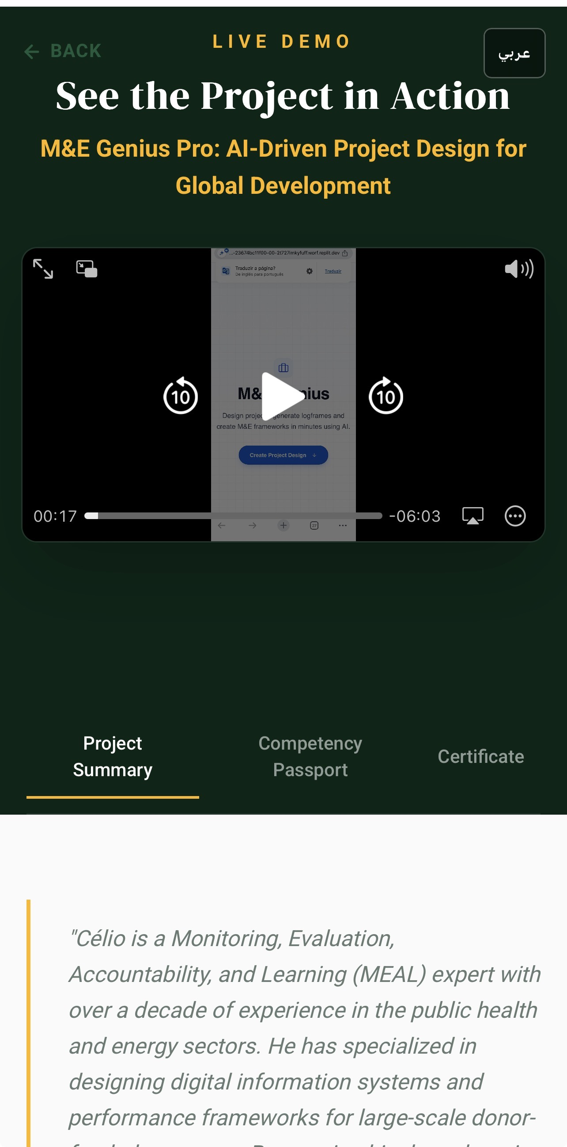
Project Summary Tab: Célio's portfolio within the Kanz AI showcase, demonstrating M&E Genius Pro as a featured project. This certification validates successful completion of the AI Training Hackathon by accredited institutions.
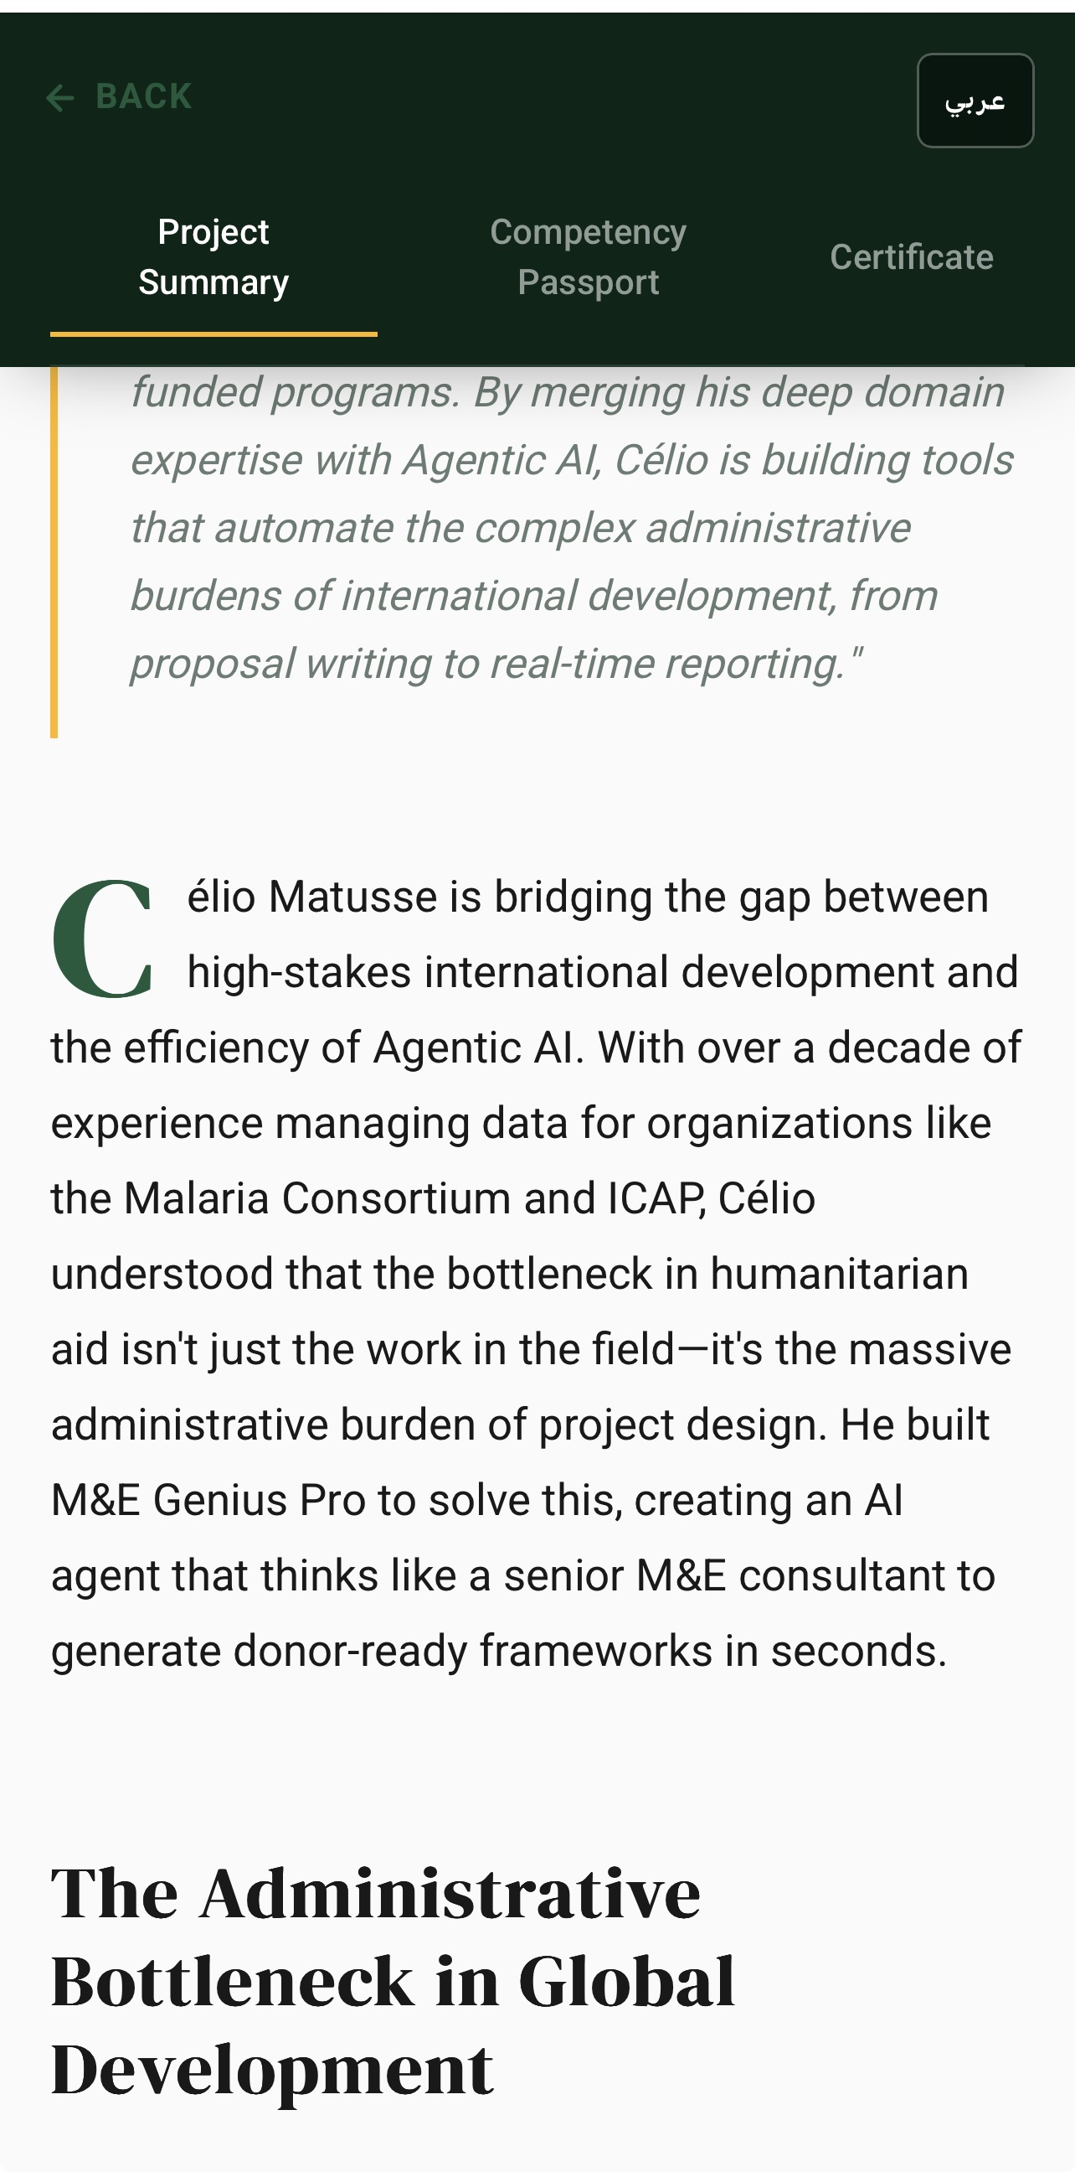
Solution Overview: Core product interface highlighting M&E Genius Pro's capability to design projects, generate logical frameworks, and create M&E systems in minutes using AI. Shows speed and quality advantages.
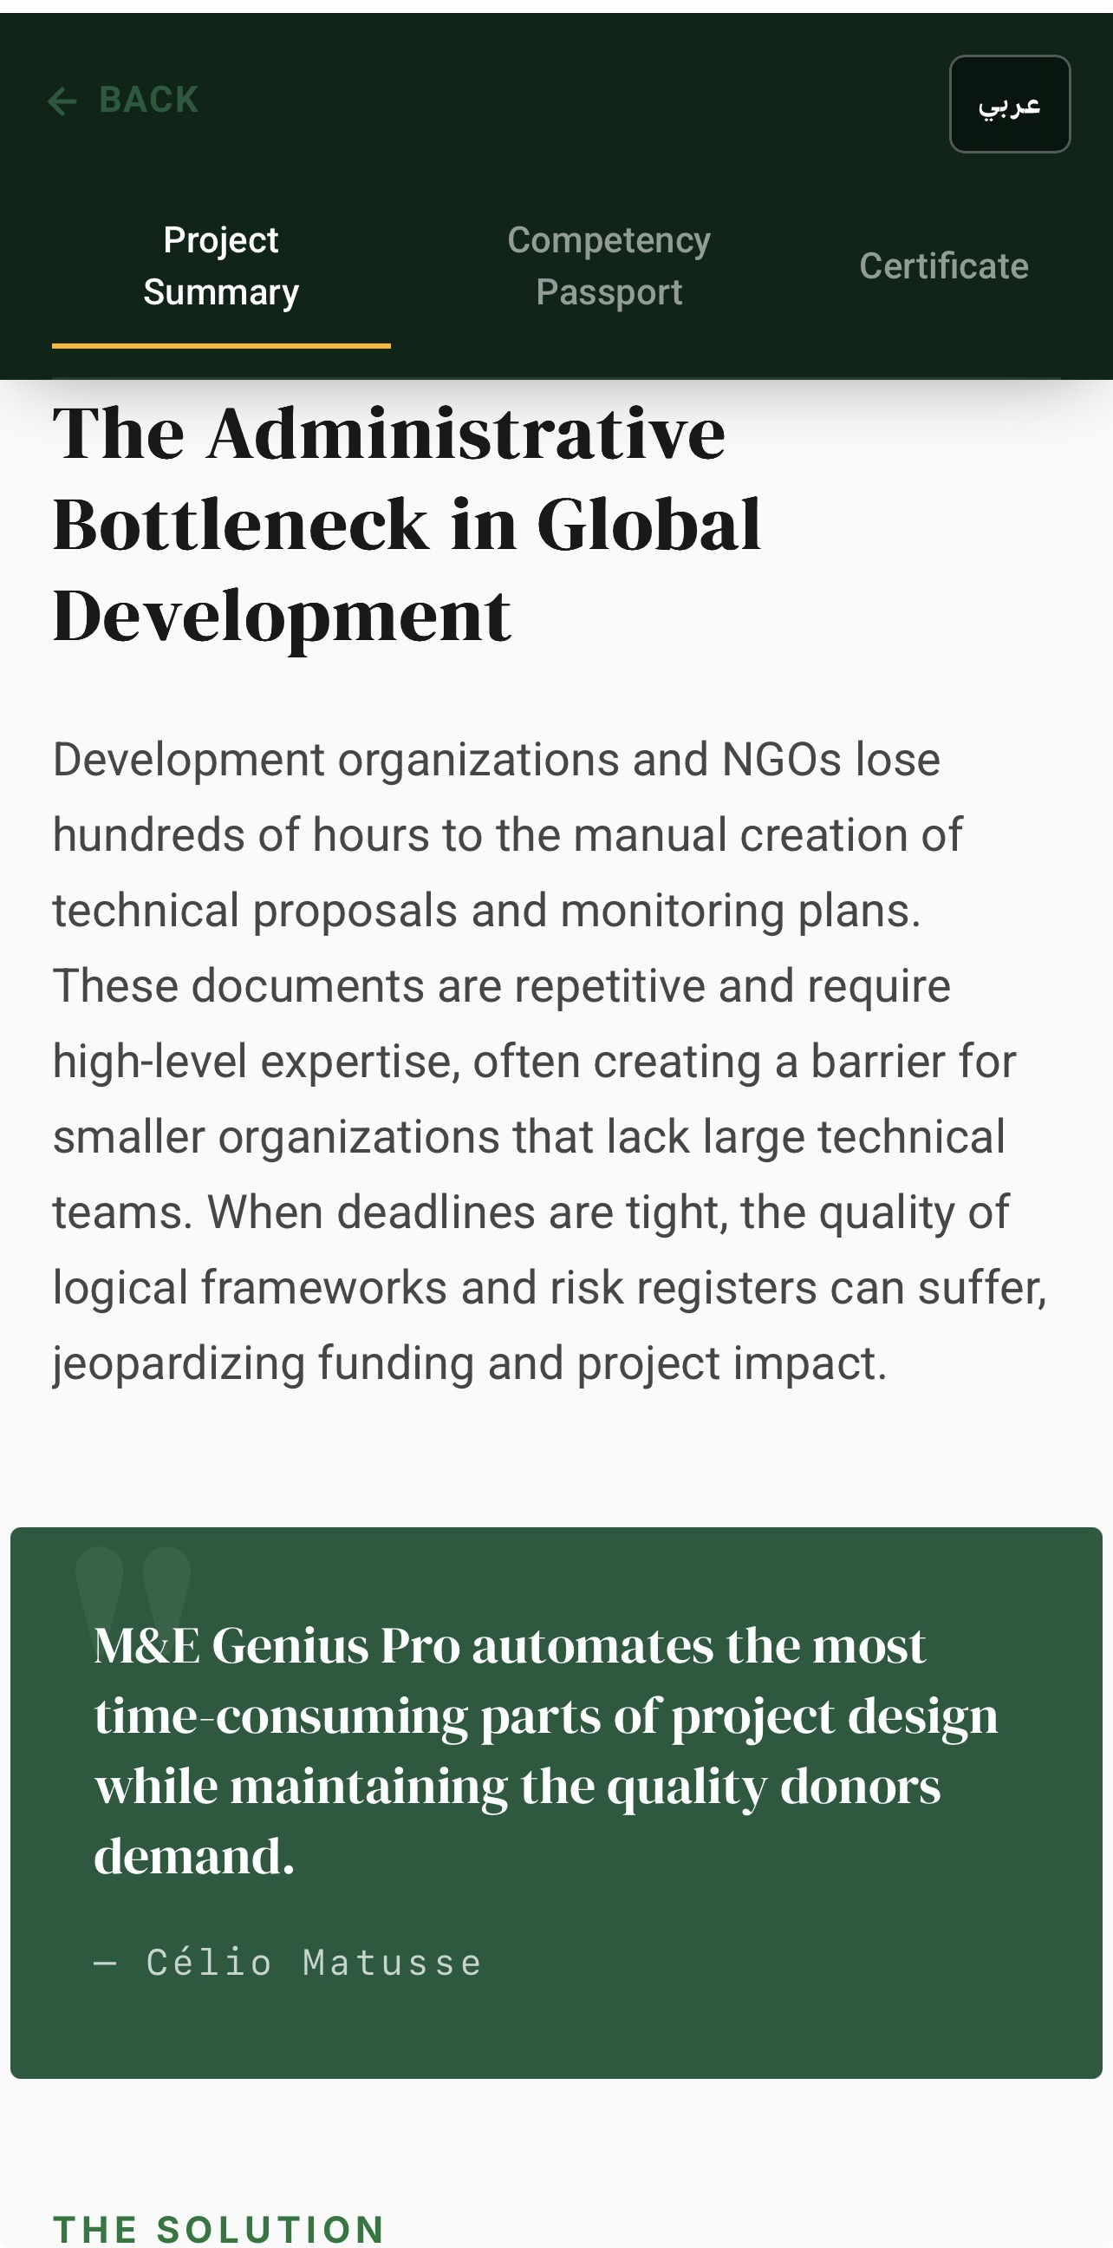
SMART Indicators Generation: Automatic creation of indicators aligned to Results-Based Management (RBM) principles used by UNDP, UNICEF, and major bilateral donors. Users generate complete SMART indicator tables for their context.
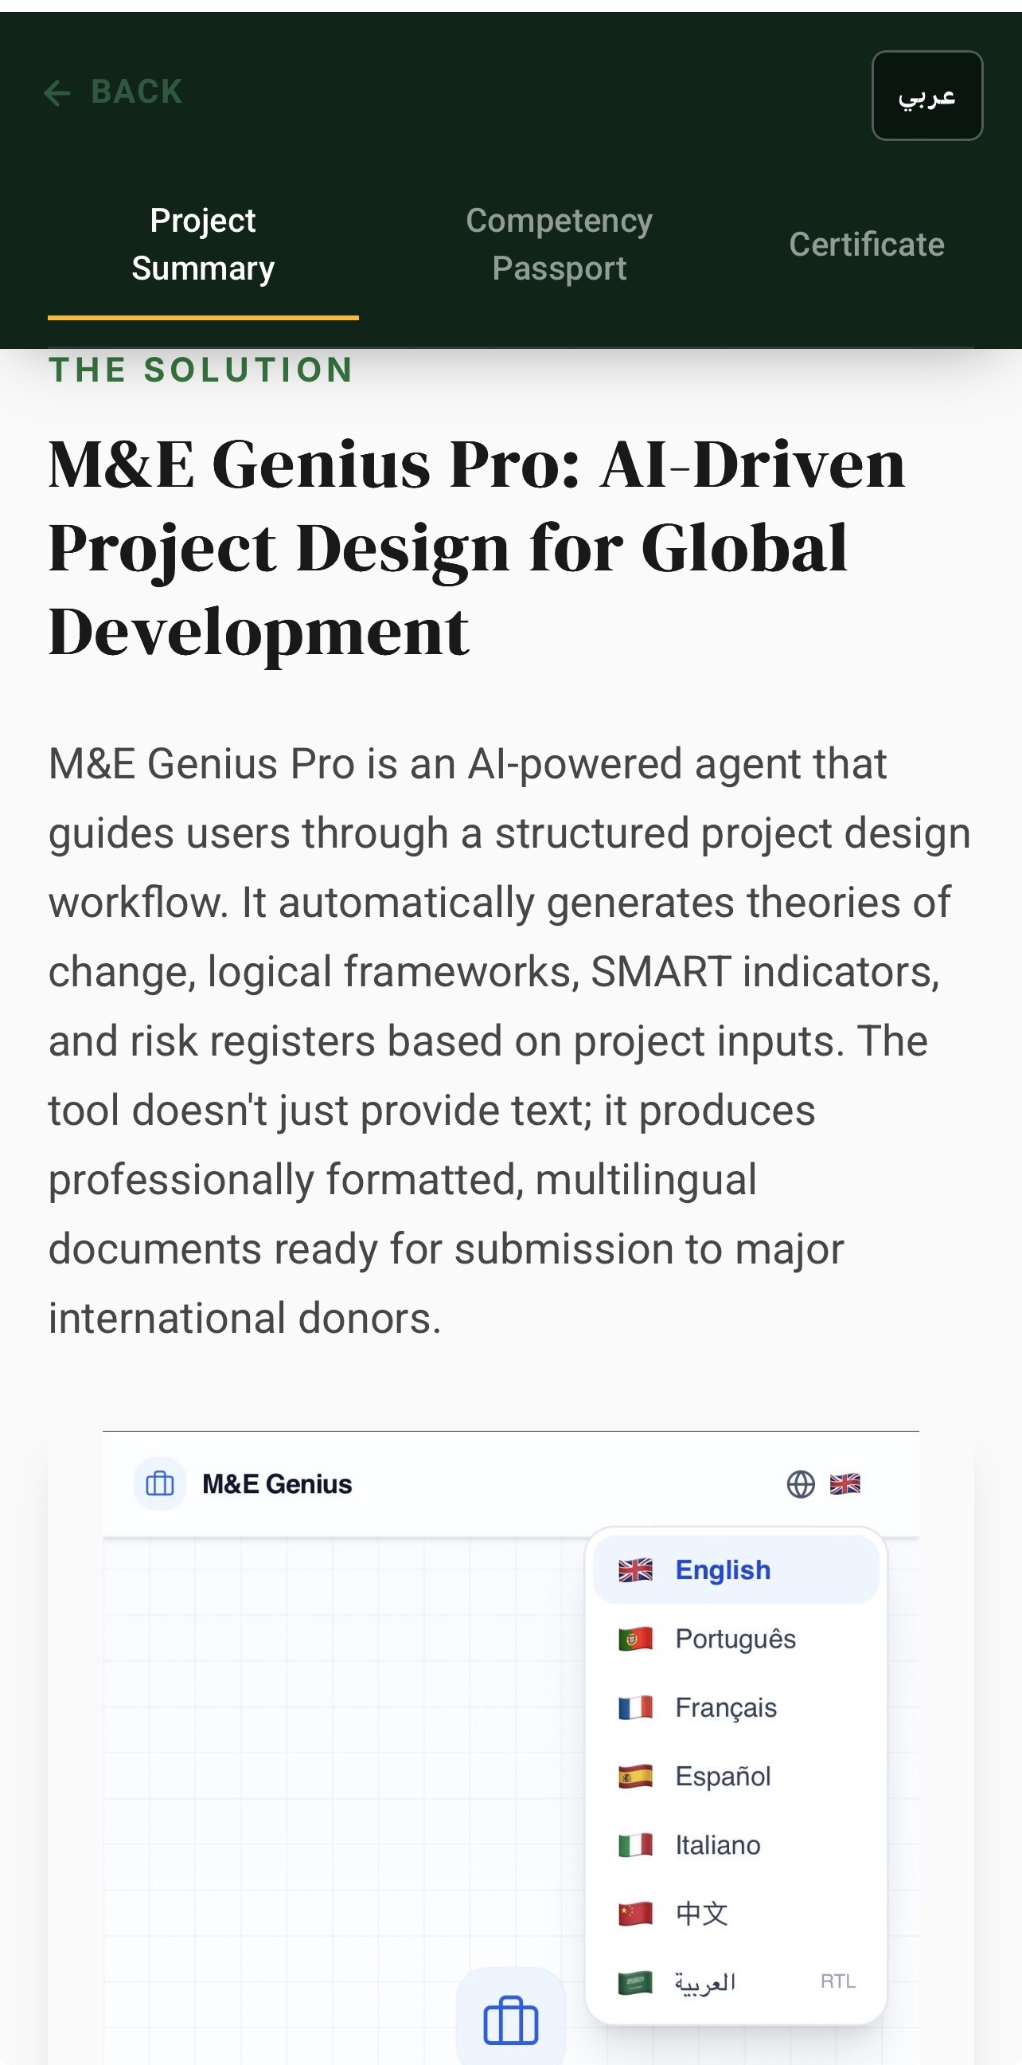
Theory of Change Visualization: Interactive results chain diagrams generated automatically, showing logical flow from project inputs through activities, outputs, outcomes, and impacts. Accelerates traditionally time-consuming design.
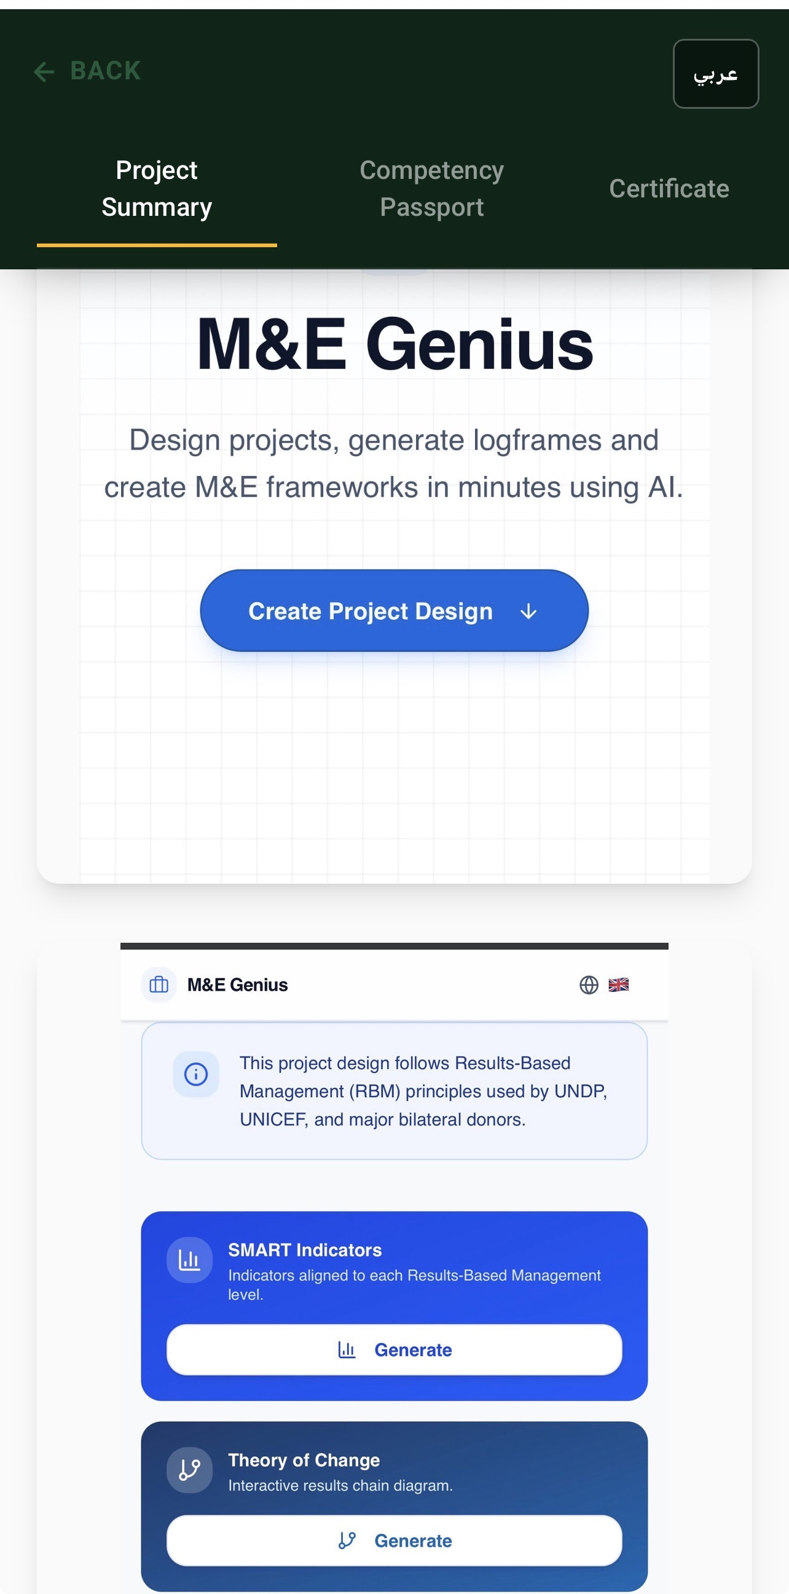
Risk Matrix with Mitigations: Heat-map risk registers generated with context-specific mitigation strategies. Addresses critical donor requirements for comprehensive risk management and implementation contingency planning.
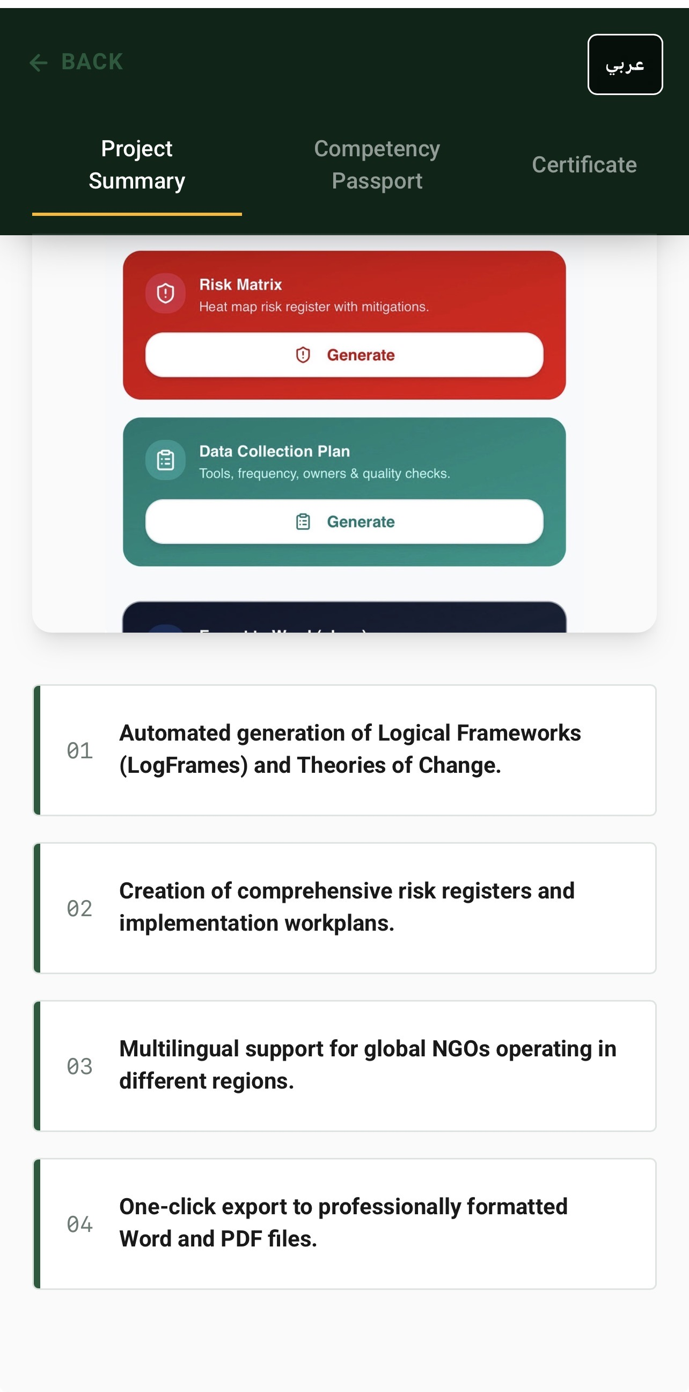
Data Collection Planning: Structured templates for collection tools, frequency, responsible parties, and quality checks. Ensures feasibility, clarity, and operational readiness for implementation teams managing field activities.

Key Product Capabilities (Current Prototype)
• Automated generation of Results-Based Management logical frameworks aligned to international donor standards
• AI-powered SMART indicator creation customized to specific project contexts and organizational requirements
• Interactive theory of change diagrams visualizing results chains from project activities through long-term impacts
• Comprehensive risk matrices with context-specific mitigation strategies for implementation challenges
• Data collection plans with specified tools, frequency, responsible parties, and quality assurance protocols
• Multilingual support (English, Portuguese, French, Spanish, Arabic, Chinese) serving global development teams
• One-click export to professionally formatted Word and PDF documents ready for submission to major donors

Project Timeline
From Concept to Working Prototype
✓ Completed • Current Status → Future Milestone
✓ 2013–2026
Professional Foundation
13+ years of specialized experience in Monitoring, Evaluation, Accountability & Learning across public health, NGO operations, and international development sectors.

✓ June 2026
Kanz AI Hackathon Enrollment
Recognized opportunity to apply advanced AI techniques to the M&E project design challenge. Enrolled in the Kanz AI Academy AI Training Hackathon.

✓ July 2026
Prototype Development
Designed and built the first working version of M&E Genius Pro during the intensive hackathon training program. Successfully completed the AI Training Hackathon.

✓ July 2026
Official Certification
Received Certificate of Workshop Completion (ID: KANZ-ADV-3114) from Lebanese American University Academy of Continuing Education, validating successful project completion and certification by accredited institutions.

✓ July 2026
Public Portfolio Launch
Published official Kanz AI Portfolio (https://try.ka.nz/ai/celiomatusse) featuring M&E Genius Pro as an AI Showcase Featured Project.

✓ July–August 2026
Investor-Grade Documentation
Produced comprehensive materials for investor evaluation: Investor Edition, Enterprise Handbook, Sales Deck, and Founder's Book with complete technical specifications and product walkthrough.

• August 2026
Current Stage: Working Prototype
Fully functional AI-powered prototype deployed on Replit with complete documentation. Ready for market testing and pilot implementations.

• August 2026 (Now)
Development Constraint Identified
Free Replit infrastructure does not provide sufficient AI credits or resources for continued module development. Product development paused pending funding or technical partnership support.

→ Post-Funding
Resume Full Development
Upon securing capital or technical support, immediately resume building additional product modules, partnerships, and pilot implementations with target organizations.

All dates and milestones verified through official Kanz AI Academy certification, portfolio records, and project documentation.

