PRODUCT REFERENCE GUIDE — FINAL DELIVERY
M&E Genius Pro
Delivery 5 — Product Launch Master Narrative & Visual Storyboard

VERSION 1.0
The consolidated master narrative and scene-by-scene visual storyboard closing the M&E Genius Pro Product Reference Guide (Deliveries 1–5)
Prepared by
Célio Matusse
Founder
Maputo, Mozambique

Table of Contents

1. Purpose of the Final Delivery
Delivery 5 closes the M&E Genius Pro Product Reference Guide. It converts the product evidence, architecture, and positioning established across Deliveries 1 through 4 into one consolidated master narrative and a scene-by-scene visual storyboard for the M&E Genius Pro product-launch video.
This document serves two functions: first, to communicate the product clearly and coherently to any reader — practitioner, investor, or partner; second, to guide the visual storytelling required by NotebookLM in producing the final launch video, by specifying exactly what should be shown, said, and demonstrated in each scene.
Evidence language note: this document uses three states — DEMONSTRATED OUTPUT (a completed, project-specific output exists in the supplied evidence), INTERFACE / FEATURE SHOWN (the module and its entry point are visible; a generated example was not supplied), and PLANNED / FUTURE CAPABILITY (a possible future direction, not an existing feature). These states are applied consistently and are carried forward unchanged from Deliveries 2–4.

2. The Product in One Sentence
M&E Genius Pro is an AI-powered Monitoring & Evaluation platform that turns one structured project input into a connected set of professional M&E, documentation, and proposal outputs — built by an M&E practitioner, for M&E practitioners, consultants, NGOs, and donor-funded programmes.
This single sentence carries the whole product story: what it is (an AI-powered M&E platform), who it serves (practitioners, consultants, NGOs, implementing partners, donor-funded programmes), the problem it addresses (fragmented, manually-repeated M&E work), and what makes its workflow distinctive (one structured input, many connected outputs).

3. The Problem
Monitoring & Evaluation and project-design work is typically produced across a fragmented set of templates and tools rather than a single connected system. In practice, this means:
- Disconnected templates for results frameworks, indicators, Theory of Change, risk registers, and data collection plans
- The same project information — objectives, geography, sector, donor, timeframe — re-entered manually at each stage
- Fragmented M&E planning, with each component developed as a separate exercise
- Proposal preparation treated as a separate activity from project design, often reconciled by hand against the framework
- Documentation assembled manually from multiple source files before it is donor-ready
- Funding discovery handled as a separate, manual search process, disconnected from the project design itself
None of this is unique to any one organisation — it is a structural feature of how M&E and proposal work is typically produced. The purpose of establishing this problem is simple: it is what gives a connected workflow its value.

4. The M&E Genius Pro Solution
ONE STRUCTURED PROJECT INPUT. MULTIPLE CONNECTED PROFESSIONAL OUTPUTS.
M&E Genius Pro responds to this fragmentation directly: it connects project design, M&E architecture, documentation, proposal development, and funding discovery within a single platform. Project information is captured once, at intake, and carries through every subsequent stage of the workflow.
The platform is positioned as an AI-assisted professional workflow and productivity layer — it embeds M&E expertise into software, while professional judgement over every generated output remains with the practitioner.

5. From Field Expertise to Technology
M&E Genius Pro is not simply an AI writing assistant. It is a domain-specific M&E technology platform that converts structured project information into interconnected monitoring, evaluation, management, and proposal-development outputs.
The platform's founder, Célio Matusse, brings practical field experience from more than thirteen years working across international development programmes, public health initiatives, and donor-funded projects. The product's structure — a single structured intake feeding a Results-Based Management framework, followed by connected M&E planning modules and proposal development — reflects a practitioner's own recurring professional workflow, built from real-world M&E practice and translated into an AI-enabled product.
This is the origin story behind the platform: expert domain knowledge, translated into technology — not a generic AI tool retrofitted with M&E terminology.

6. The Six-Field Project Input
Every M&E Genius Pro workflow begins with a single structured screen — six fields that capture the core project parameters:
- Project Name
- Country
- Sector
- Donor
- Duration
- Project Objective
This is not simply a form. It is the structured entry point from which every downstream module in the workflow is built: the Results-Based Management framework, SMART Indicators, Theory of Change, Risk Matrix, Data Collection Plan, M&E documentation, and Technical Proposal all trace back to this one input.
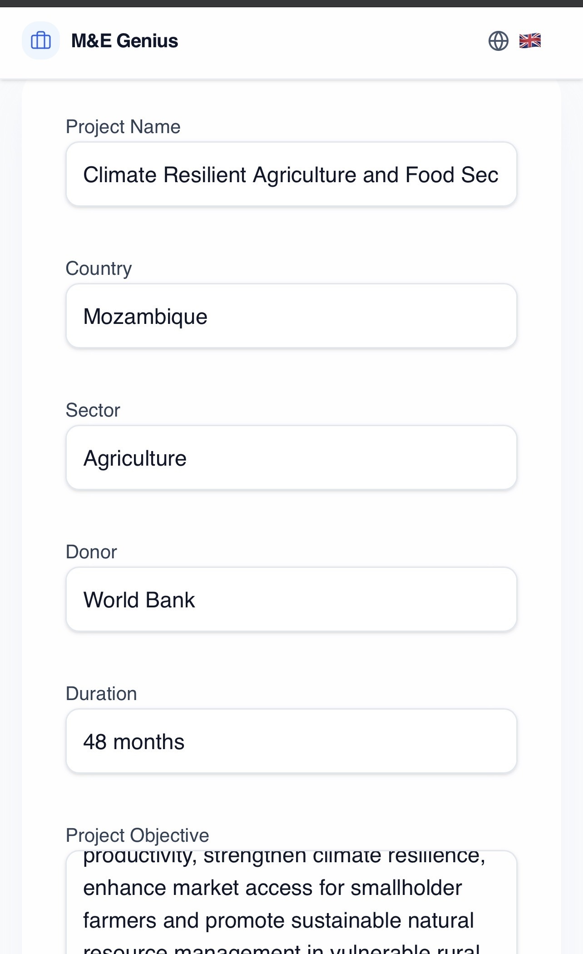
Figure 1. The Project Parameters screen, populated with a worked example (Mozambique / Agriculture / World Bank / 48 months).

7. The Product Workflow
The platform connects ten stages into a single system. This is the backbone of the entire product story: one input, carried through a connected chain of professional outputs.
PROJECT INPUT
Six structured fields
↓
PROJECT DESIGN
↓
RESULTS-BASED MANAGEMENT FRAMEWORK
Generated Overall Goal
DEMONSTRATED OUTPUT
↓
SMART INDICATORS
INTERFACE / FEATURE SHOWN
↓
THEORY OF CHANGE
INTERFACE / FEATURE SHOWN
↓
RISK MANAGEMENT
INTERFACE / FEATURE SHOWN
↓
DATA COLLECTION PLAN
INTERFACE / FEATURE SHOWN
↓
M&E DOCUMENTATION
INTERFACE / FEATURE SHOWN
↓
WORD / PDF OUTPUT
INTERFACE / FEATURE SHOWN
↓
TECHNICAL PROPOSAL
Generated Word (.docx) proposal
DEMONSTRATED OUTPUT
↓
FUNDING OPPORTUNITY DISCOVERY
INTERFACE / FEATURE SHOWN

The table below summarises each stage for quick reference; a full scene-by-scene treatment, including narration and visual evidence, follows in Section 22.
Module | Input | AI-Assisted Process | Output | Why It Matters
Project Design | Six structured project fields | Structures parameters for downstream use | A structured project profile | Foundational — every module below builds on this input
RBM Framework | Structured project profile | Generates Overall Goal & results architecture | Project-specific RBM framework | Establishes the results basis for indicators, ToC, and the proposal
SMART Indicators | RBM framework | Structures indicators per results level | Indicator set aligned to the framework | Provides the measurement basis for the Data Collection Plan
Theory of Change | RBM framework, objective | Builds results-chain logic | Theory of Change diagram | Strengthens the narrative used in the Technical Proposal
Risk Management | Project design, framework | Identifies & categorises risks | Risk matrix with mitigations | Feeds the Data Collection Plan and the proposal narrative
Data Collection Plan | SMART indicators | Structures tools, frequency, owners, checks | Operational data collection plan | Completes the M&E framework ahead of documentation
M&E Documentation | All framework components | Compiles into one structured document | Structured M&E document | Feeds Word / PDF export
Word / PDF Output | M&E documentation | Formats and exports | Word (.docx) / PDF file | Delivers the framework in a reusable, shareable format
Technical Proposal | Project design, RBM framework | Builds multi-section proposal narrative | Generated Word (.docx) proposal | Converts design work directly into a donor-ready draft
Funding Discovery | Project design | Matches project to funding opportunities | Matched funding opportunities | Extends the workflow beyond documentation

8. Results-Based Management Framework
This is one of the strongest demonstrated moments in the product. From the six structured fields entered at intake, the platform generates a project-specific results architecture: Overall Goal, Objectives, Results, Outputs, Activities, and Indicators, aligned to Results-Based Management practice.
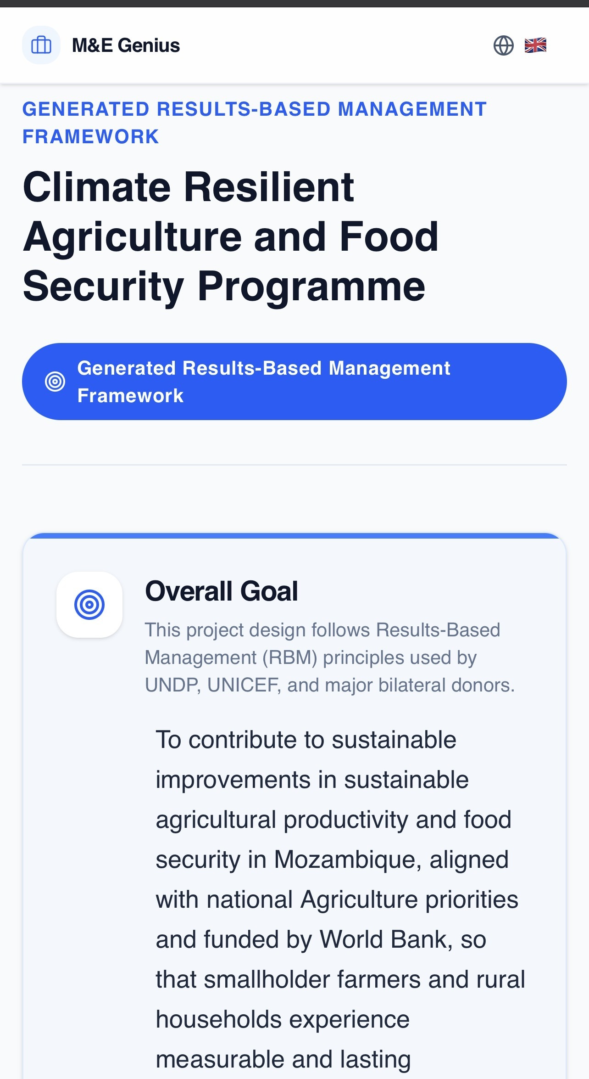
Figure 2. The generated Results-Based Management Framework, showing the project title and a project-specific Overall Goal narrative — demonstrated output.
The Overall Goal narrative shown above is not fixed template text: it dynamically reflects the country, sector, and donor entered at intake (Mozambique, Agriculture, World Bank, in the supplied example). This is the clearest evidence in the current product of structured input becoming a professional, project-specific output.

9. SMART Indicators
The SMART Indicators module extends the RBM Framework into measurable detail: indicators generated in alignment with each results level, rather than developed as a separate, independent exercise.
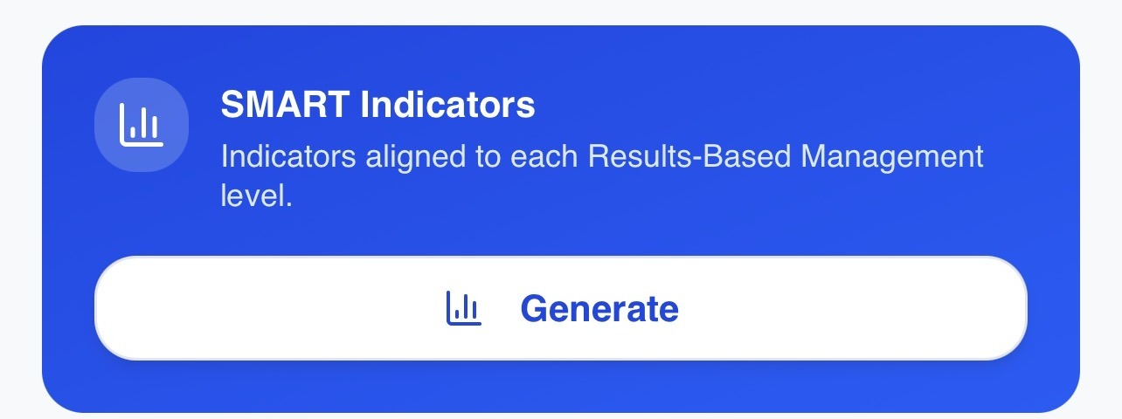
Figure 3. SMART Indicators module card, showing its description and Generate action — interface / feature shown.
The module and its generation action are visible in the interface. A generated, project-specific indicator set was not included in the supplied evidence; this is listed as a visual item still required in Section 23.

10. Theory of Change
The Theory of Change module is the platform's visualisation of causal logic: the relationships between Inputs, Activities, Outputs, Outcomes, and Impact, presented as an interactive results-chain diagram.
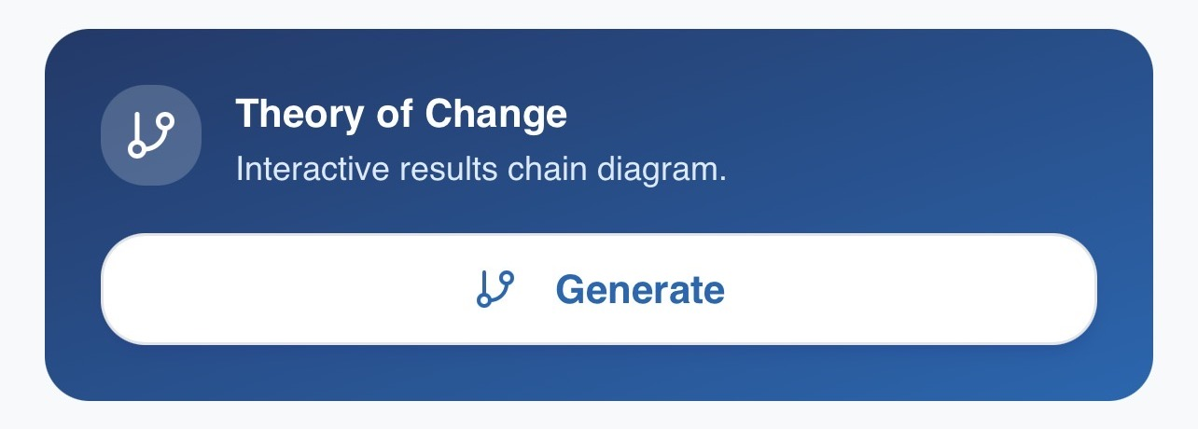
Figure 4. Theory of Change module card, showing its description and Generate action — interface / feature shown.
The module and its generation action are visible in the interface. A generated diagram was not included in the supplied evidence; this is marked as a visual item still required in Section 23, rather than presented as an existing example.

11. Risk Matrix
The Risk Matrix module integrates risk management into project design from the outset: identifying risks, categorising them, assessing likelihood and severity, prioritising them, and pairing them with mitigation measures — presented as a heat-map style view.
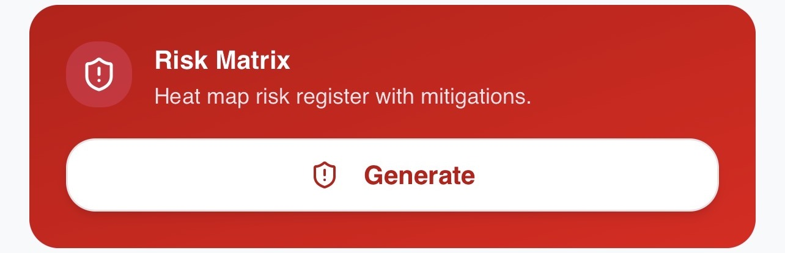
Figure 5. Risk Matrix module card, showing its description and Generate action — interface / feature shown.
The module and its generation action are visible in the interface. A generated risk matrix was not included in the supplied evidence; this is marked as a visual item still required in Section 23.

12. Data Collection Plan
Design becomes an operational field plan.
The Data Collection Plan module converts the M&E framework into an operational structure: each indicator paired with a data source or tool, a collection frequency, a responsible owner, and a quality check.
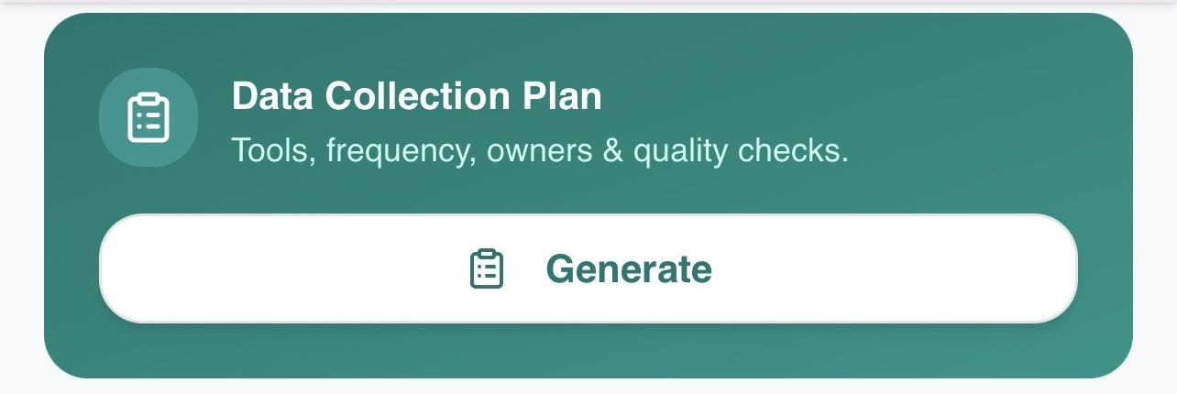
Figure 6. Data Collection Plan module card, showing its description and Generate action — interface / feature shown.
The module and its generation action are visible in the interface. A generated data collection plan was not included in the supplied evidence; this is marked as a visual item still required in Section 23.

13. M&E Documentation & Word Export
The platform does not stop at generating content on screen. Its documentation capability compiles the RBM Framework, Indicators, Theory of Change, Risk Matrix, and Data Collection Plan into structured, reusable documentation, with an export action to Word (.docx).
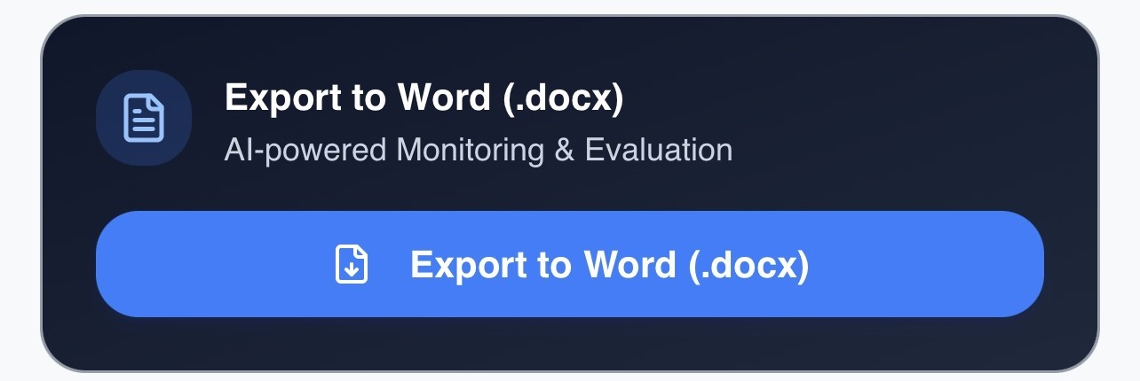
Figure 7. Export to Word (.docx) card — interface / feature shown.
The export option is visible in the interface. A distinct, completed M&E documentation file — separate from the Technical Proposal file documented in Sections 14–15 — was not included in the supplied evidence; this is marked as a visual item still required in Section 23.

14. AI Proposal Writer
This is one of the strongest sections of the product story. The AI Proposal Writer uses the project information already captured at intake as the direct basis for proposal development — structuring it into a donor-ready Technical Proposal, rather than functioning as generic AI text generation.
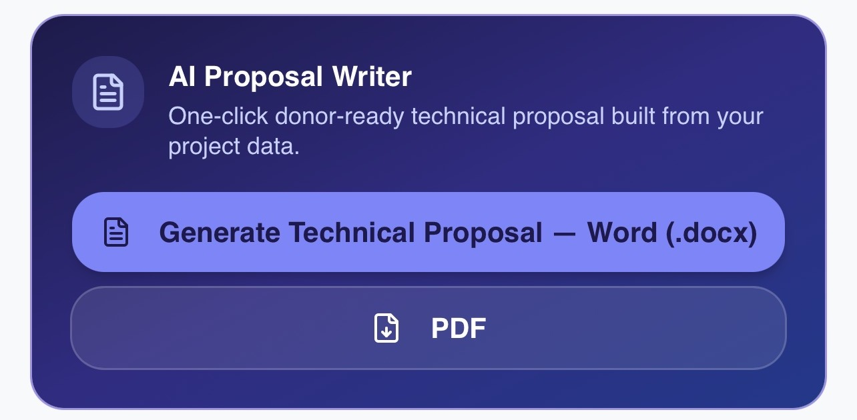
Figure 8. AI Proposal Writer card, showing the "Generate Technical Proposal — Word (.docx)" action and a PDF option — demonstrated output.
The generation action shown above is confirmed by a completed output file, documented in Section 15. This module is the clearest bridge in the platform between M&E design and donor engagement: proposal preparation is typically one of the most resource-intensive activities for consultants and NGOs, and this is where that effort is most directly reduced.

15. Technical Proposal Output
STRUCTURED INPUT → PROFESSIONAL OUTPUT.
The supplied evidence includes direct, multi-part confirmation that a Technical Proposal was generated: the completed file, its cover page, and its Table of Contents.
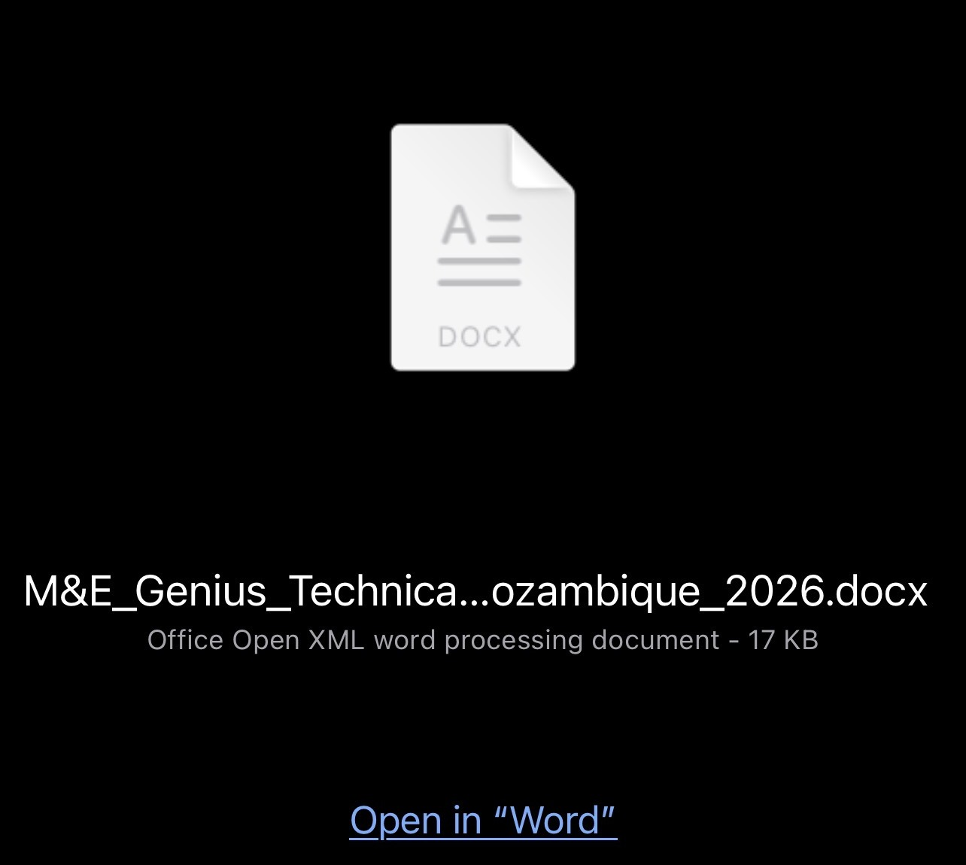
Figure 9. The generated file, confirmed as a 17 KB Word (.docx) document.
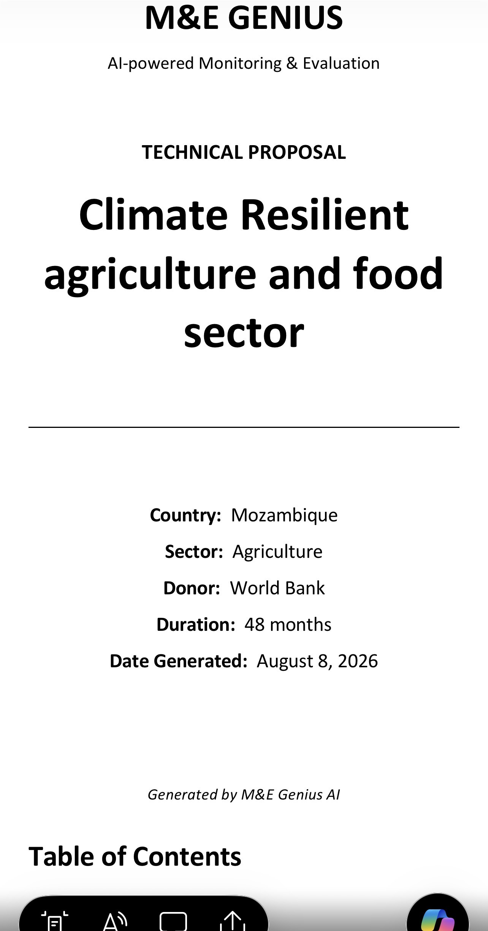
Figure 10. The generated Technical Proposal cover page, with project title, country, sector, donor, duration, and date generated.
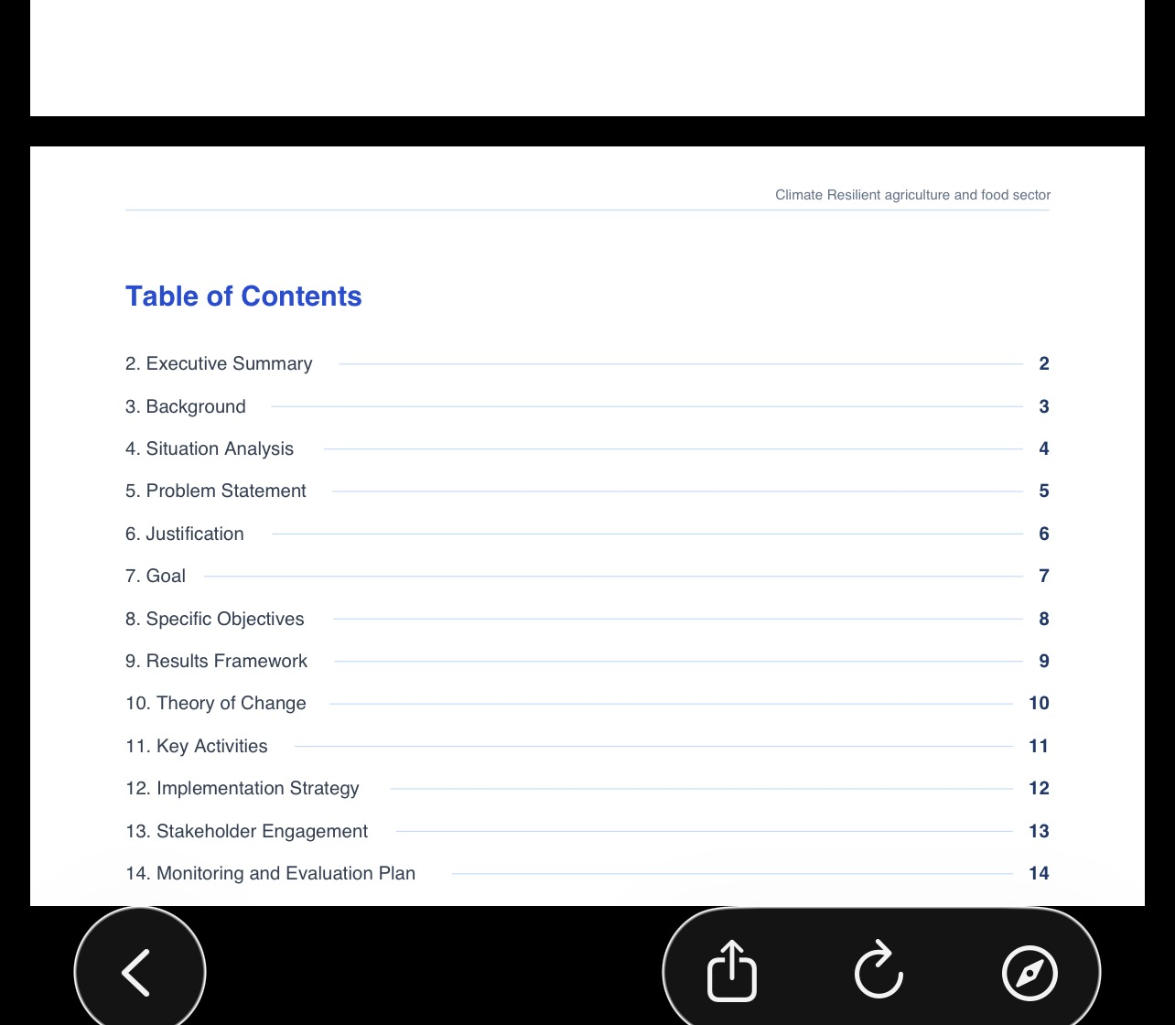
Figure 11. The generated Technical Proposal Table of Contents, listing 13 structured sections.
A page indicator in the same preview confirms the document extends to approximately 23 pages. Together, these three artifacts make the Technical Proposal the single strongest concrete demonstration in the current product of the platform's core mechanism: structured input becoming professional, reviewable output.

16. PDF Output
The AI Proposal Writer interface presents a PDF option alongside the Word (.docx) generation action (see Figure 9 in Section 14). Word generation is demonstrated through the completed proposal documented in Section 15.
A completed PDF file was not included in the supplied evidence. PDF export is accurately described here as INTERFACE / FEATURE SHOWN — visibly offered, not yet confirmed by a completed output. This item is listed for collection in Section 23.

17. AI Donor Opportunity Finder
The workflow extends beyond project design and documentation into funding discovery: project characteristics captured at intake are used to match the project against potential funding opportunities.

Figure 12. AI Donor Opportunity Finder card, showing its "Find Funding Opportunities" action — interface / feature shown.
The module and its entry point are visible in the interface. A completed results screen was not included in the supplied evidence, and no specific donor opportunity is stated or implied by this guide; this is marked as a visual item still required in Section 23.

18. Multilingual Platform
The platform interface is available in seven languages: English, Português, Français, Español, Italiano, 中文, and العربية, with Arabic presented as a right-to-left (RTL) language.
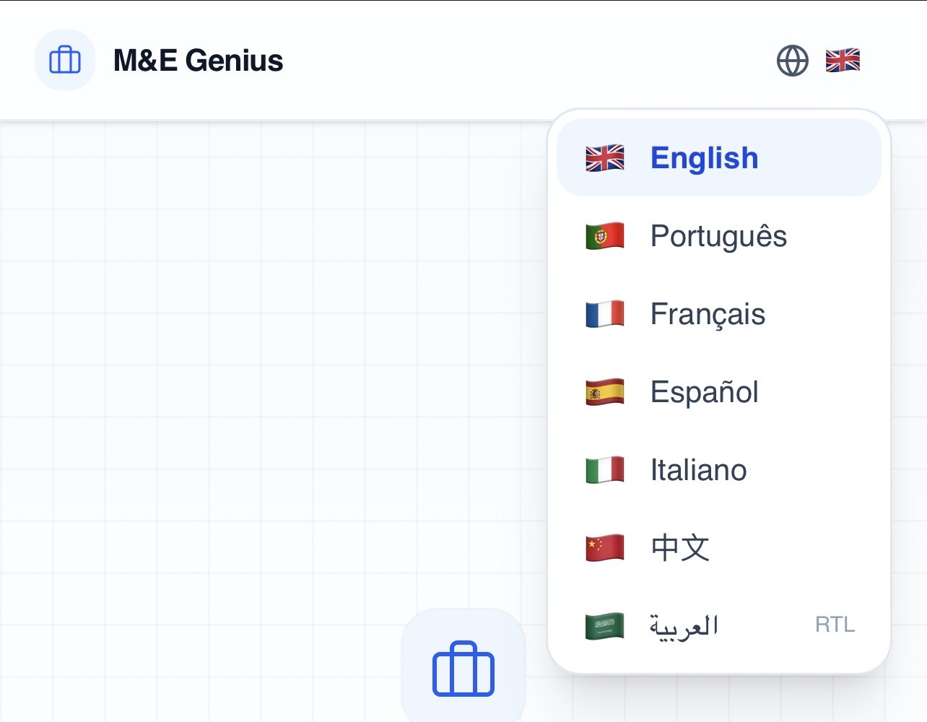
Figure 13. The language selector, showing all seven interface languages — interface / feature shown.
This is a multilingual user interface. It is distinct from multilingual generated content or document-language support — the platform does not claim, and this guide does not claim, that generated documents such as the Technical Proposal are automatically produced in all seven languages.

19. The Connected Workflow Advantage
The value of M&E Genius Pro is not that it has an AI writer, an indicator generator, a risk module, and a proposal generator as separate features. The value is that these functions are organised around a shared M&E workflow, built from the same structured project input.
- Structured input, entered once, rather than re-entered at every stage
- Consistency between the framework, indicators, risk view, and proposal narrative, because they share the same source data
- Workflow continuity from project design through to funding discovery
- Reduced repetition across what would otherwise be separate manual exercises
- Professional, reusable outputs rather than on-screen content alone
- Domain-specific logic, built around Results-Based Management practice rather than general-purpose drafting
- A workflow structure that is not tied to one sector, project, or country — it scales with whatever parameters are entered
- Applicability to both individual consultants and larger implementing organisations
This is the central investor-facing argument of the platform: the architecture, not any single feature, is what creates the product's value.

20. Investor Value
The product architecture translates into commercial logic along several dimensions, distinguishing current capability from future potential throughout.

Current Product Capability
- A specialised, recurring professional workflow (M&E design and documentation), not a general-purpose AI writing tool
- Domain expertise embedded directly into the product's structure, reflecting Results-Based Management practice
- A demonstrated generation loop — structured input producing a project-specific RBM Framework and a professional Technical Proposal
- A connected set of M&E planning modules (indicators, Theory of Change, risk, data collection) visible within the same workflow
- A seven-language interface, relevant to multi-country donor operations and international consulting firms
- A target-user base spanning individual consultants through to NGOs, INGOs, and donor-funded programmes

Future Product Potential
- Deeper integration between the M&E planning modules and the generated framework
- Expanded reporting and data-quality workflows
- Broader proposal and donor-matching workflows
- Organisational collaboration features
- Additional sector-specific workflow variants
- Potential SaaS / productisation pathways building on the existing connected-workflow architecture
This document does not include market-size figures, revenue figures, customer numbers, adoption figures, performance percentages, or funding commitments, as none are documented in the existing source material.

21. Competitive Differentiation
M&E expertise + AI-assisted generation + integrated workflow + professional document outputs + proposal generation + funding discovery.
Each of these elements exists elsewhere in some form: templates, general AI writing tools, standalone document generators. What differentiates M&E Genius Pro, based on its own architecture, is that these elements are combined and integrated around a single, M&E-specific workflow rather than offered as separate tools.
This guide does not claim the absence of competitors, or that the platform is the first of its kind, fully autonomous, or completely automated. Its differentiation is described strictly in terms of the combination and integration of its own capabilities.

22. Final NotebookLM Video Storyboard
The scene sequence below is written to build momentum as a premium technology product launch, not a software tutorial. Each scene specifies its purpose, the exact visual to use, on-screen text, suggested narration, the transition to the next scene, and the underlying investor message.

Scene 1 — The Problem
Purpose | Open on the professional pain point, not the product.
Visual / screenshot to show | Abstract/generic opening visual — no product screenshot yet. [No screenshot required]
On-screen text | "M&E work shouldn't take weeks."
Narration | Monitoring and Evaluation professionals spend days, sometimes weeks, producing the documents every donor-funded project needs — frameworks, indicators, proposals — across templates that don't talk to each other.
Transition to next scene | Cut from the problem statement to the fragmentation visual.
Investor message | Establishes market pain before any product claim is made.

Scene 2 — The Fragmentation
Purpose | Make the fragmentation feel concrete and familiar.
Visual / screenshot to show | Simple on-screen graphic listing disconnected templates/tools. [No screenshot required — motion graphic]
On-screen text | "Disconnected templates. Repeated data entry. Documents built by hand."
Narration | Results frameworks in one file. Indicators in another. Risk registers, data plans, and proposals each redone from scratch — the same project information, re-typed again and again.
Transition to next scene | Transition to the M&E Genius Pro logo reveal.
Investor message | Sets up the specific inefficiency the product is built to remove.

Scene 3 — Introducing M&E Genius Pro
Purpose | Introduce the product and its one-sentence positioning.
Visual / screenshot to show | IMG_1310.jpg — the M&E Genius Pro landing screen.
On-screen text | "M&E Genius Pro — Design projects, generate logframes, and create M&E frameworks in minutes using AI."
Narration | M&E Genius Pro is an AI-powered Monitoring & Evaluation platform that turns one structured project input into a connected set of professional outputs.
Transition to next scene | Cut to the founder-story visual.
Investor message | First frame the audience sees of the actual product — establishes it is real, not conceptual.

Scene 4 — From Field Expertise to Technology
Purpose | Establish credibility through founder domain expertise.
Visual / screenshot to show | Founder name/title card. [No new screenshot required]
On-screen text | "From field expertise to technology."
Narration | Built by an M&E practitioner with over a decade of field experience across international development, public health, and donor-funded programmes — not a generic AI tool retrofitted with M&E terms.
Transition to next scene | Transition into the product walkthrough, starting with project input.
Investor message | Domain credibility is a core differentiator investors should register early.

Scene 5 — Six-Field Project Input
Purpose | Show the single structured starting point of the workflow.
Visual / screenshot to show | crop_params_filled.jpg — Project Parameters screen, populated example.
On-screen text | "One structured input. Project Name · Country · Sector · Donor · Duration · Objective."
Narration | Every project starts with six fields — captured once, and reused across the entire workflow that follows.
Transition to next scene | Cut directly to the generated RBM Framework, showing the transformation.
Investor message | This is the mechanism investors need to understand before anything else: one input, many outputs.

Scene 6 — RBM Framework
Purpose | Deliver the first concrete 'wow' moment — generation in action.
Visual / screenshot to show | crop_rbm.jpg — generated RBM Framework with project-specific Overall Goal.
On-screen text | "From six fields to a results framework — in seconds."
Narration | The platform generates a project-specific Results-Based Management framework, with an Overall Goal built directly from the entered parameters.
Transition to next scene | Transition to SMART Indicators as the next connected module.
Investor message | The first demonstrated proof point: structured input becoming a professional output.

Scene 7 — SMART Indicators
Purpose | Show the framework extending into measurable detail.
Visual / screenshot to show | crop_smart_indicators.jpg — SMART Indicators module card.
On-screen text | "Indicators aligned to every level of the framework."
Narration | Indicators are generated in line with the results framework, not developed as a separate exercise.
Transition to next scene | Move to Theory of Change as the next connected module.
Investor message | Demonstrates workflow breadth beyond the framework alone.

Scene 8 — Theory of Change
Purpose | Visualise causal logic as an AI-assisted capability.
Visual / screenshot to show | crop_theory_of_change.jpg — Theory of Change module card.
On-screen text | "See the causal logic — activities to impact."
Narration | The platform helps practitioners visualise and test the causal logic connecting activities to outcomes and impact.
Transition to next scene | Move to Risk Matrix.
Investor message | A visual, memorable moment — causal logic made visible rather than left implicit.

Scene 9 — Risk Matrix
Purpose | Show risk management embedded in design, not bolted on later.
Visual / screenshot to show | crop_risk_matrix.jpg — Risk Matrix module card.
On-screen text | "Risk, structured from day one."
Narration | Project risks are identified, categorised, and paired with mitigation measures as part of the design process itself.
Transition to next scene | Move to Data Collection Plan.
Investor message | Signals professional rigour and donor-readiness.

Scene 10 — Data Collection Plan
Purpose | Show design becoming an operational field plan.
Visual / screenshot to show | crop_data_collection.jpg — Data Collection Plan module card.
On-screen text | "Design becomes an operational field plan."
Narration | Tools, frequency, ownership, and quality checks — connected directly to the indicators the project is already measuring.
Transition to next scene | Move to M&E Documentation.
Investor message | Shows the workflow reaching implementation, not stopping at design.

Scene 11 — M&E Documentation
Purpose | Show the framework compiled into one document.
Visual / screenshot to show | crop_export_word.jpg — Export to Word (.docx) card.
On-screen text | "One structured M&E document — not five disconnected files."
Narration | The full framework compiles into structured, professional documentation, ready for export.
Transition to next scene | Move to Word Export as the tangible output.
Investor message | Reinforces the fragmentation-to-integration story from Scenes 1–2.

Scene 12 — Word Export
Purpose | Make the output feel tangible, not theoretical.
Visual / screenshot to show | crop_file_preview.jpg — the generated file, confirmed as a Word (.docx) document.
On-screen text | "A real file. A real document."
Narration | Generated content becomes a real, editable Word file — ready to review, edit, and share in the format teams already use.
Transition to next scene | Move to AI Proposal Writer as the next major capability.
Investor message | Converts the on-screen demo into a credible, tangible deliverable.

Scene 13 — AI Proposal Writer
Purpose | Present the strongest commercial capability in the platform.
Visual / screenshot to show | crop_ai_proposal_writer.jpg — AI Proposal Writer card, showing "Generate Technical Proposal — Word (.docx)".
On-screen text | "From project data to donor-ready proposal."
Narration | The same project information already captured becomes the basis for a structured, donor-ready Technical Proposal — not generic AI text generation, but structured proposal architecture.
Transition to next scene | Cut to the generated Technical Proposal itself.
Investor message | The clearest bridge between M&E design and donor engagement — where commercial value is most visible.

Scene 14 — Technical Proposal
Purpose | Deliver the strongest concrete proof point in the video.
Visual / screenshot to show | crop_proposal_cover.jpg and crop_toc.jpg — cover page and Table of Contents.
On-screen text | "Structured input. Professional output. 23 pages, generated."
Narration | A complete, structured proposal — cover page, Table of Contents, and a full multi-section draft — generated directly from the project data entered at the start.
Transition to next scene | Move to PDF and format options.
Investor message | The single strongest demonstration in the product: structured input becoming a professional, reviewable document.

Scene 15 — PDF
Purpose | Show format flexibility accurately.
Visual / screenshot to show | crop_ai_proposal_writer.jpg (PDF option visible on the same card). [Completed PDF screenshot required — see Section 23]
On-screen text | "Word or PDF — your choice."
Narration | Alongside the generated Word document, a PDF export option is available for distribution and submission.
Transition to next scene | Move to Donor Opportunity Finder.
Investor message | Keep concise — format flexibility is a supporting point, not a headline proof point.

Scene 16 — Donor Opportunity Finder
Purpose | Extend the story beyond documentation into funding.
Visual / screenshot to show | crop_donor_finder.jpg — AI Donor Opportunity Finder card.
On-screen text | "The workflow doesn't stop at the proposal."
Narration | Project characteristics already captured can be used to discover matching funding opportunities — extending the workflow into the next stage of the project cycle.
Transition to next scene | Move to Multilingual Platform.
Investor message | Signals platform scope beyond a single-purpose tool.

Scene 17 — Multilingual Platform
Purpose | Establish international readiness.
Visual / screenshot to show | crop_language.jpg — language selector showing all seven languages.
On-screen text | "Built for international teams from day one."
Narration | Seven interface languages, including Arabic with right-to-left support — designed for multi-country teams and donor operations from the outset.
Transition to next scene | Move to the connected-workflow summary.
Investor message | Supports the platform's positioning for international donors, NGOs, and consulting firms.

Scene 18 — The Connected Workflow
Purpose | Deliver the central architectural argument.
Visual / screenshot to show | A composite/summary graphic of the full workflow chain (Section 7 diagram). [No new screenshot required]
On-screen text | "One input. One connected workflow. Many professional outputs."
Narration | The value isn't any single feature — it's that every module shares the same structured input, creating a workflow instead of a toolbox.
Transition to next scene | Move to commercial value.
Investor message | The core investor argument: architecture, not features, is the product's moat.

Scene 19 — Commercial Value
Purpose | Translate the architecture into business logic.
Visual / screenshot to show | Text/graphic summary of investor value points (Section 20). [No screenshot required]
On-screen text | "Domain expertise, embedded in software."
Narration | A specialised, repeatable workflow — applicable across sectors, countries, and organisations, from individual consultants to donor-funded programmes.
Transition to next scene | Move to vision and scale.
Investor message | Prepares the audience for the scale argument without financial projections.

Scene 20 — Vision and Scalability
Purpose | Paint the growth trajectory without inventing figures.
Visual / screenshot to show | Text/graphic — expansion pathway across users and sectors. [No screenshot required]
On-screen text | "Built to scale — across consultants, organisations, sectors, and countries."
Narration | The same workflow architecture that works for one project is designed to extend across many — the foundation for a broader M&E technology platform.
Transition to next scene | Move to the closing statement.
Investor message | Signals long-term platform potential, clearly separated from current capability.

Scene 21 — Closing Statement
Purpose | End on the core positioning line with momentum.
Visual / screenshot to show | M&E Genius Pro logo / wordmark. [No new screenshot required]
On-screen text | "M&E Genius Pro. From field expertise to technology."
Narration | M&E Genius Pro: professional Monitoring & Evaluation, reimagined as one connected, AI-assisted workflow.
Transition to next scene | End card / call to action.
Investor message | Leaves the audience with the single positioning line the entire narrative has been building toward.

23. Visual Evidence Master Checklist
The table below consolidates every visual required across the storyboard in Section 22, distinguishing what is already available from previous evidence against what still needs to be collected. Screenshots already supplied are reused directly; nothing already available is requested again.
Scene | Capability | Visual Required | Available? | Source | Use in Video? | Additional Required? | Exact Screenshot Needed
3 | Landing screen | Home screen with tagline | Yes | Delivery 2 (IMG_1310) | Yes | No | —
5 | Project Parameters | Populated Project Parameters screen | Yes | Delivery 2 | Yes | No | —
6 | RBM Framework | Generated framework with Overall Goal | Yes | Delivery 2 | Yes | No | —
7 | SMART Indicators | Module card (interface) | Yes (interface only) | Delivery 2 | Yes | Yes | Generated indicator output after clicking "Generate"
8 | Theory of Change | Module card (interface) | Yes (interface only) | Delivery 2 | Yes | Yes | Generated results-chain diagram
9 | Risk Matrix | Module card (interface) | Yes (interface only) | Delivery 2 | Yes | Yes | Generated heat-map / risk register
10 | Data Collection Plan | Module card (interface) | Yes (interface only) | Delivery 2 | Yes | Yes | Generated data collection plan output
11 | M&E Documentation | Export to Word card (interface) | Yes (interface only) | Delivery 2 | Yes | Yes | Completed M&E framework file opened in Word (distinct from Technical Proposal)
12 | Word Export | Generated file preview | Yes | Delivery 2 | Yes | No | —
13 | AI Proposal Writer | Proposal Writer card with actions | Yes | Delivery 2 | Yes | No | —
14 | Technical Proposal | Cover page + Table of Contents | Yes | Delivery 2 | Yes | No | —
15 | PDF | PDF button (interface only) | Yes (interface only) | Delivery 2 | Yes | Yes | Completed PDF file, opened in a PDF viewer
16 | Donor Opportunity Finder | Module card (interface) | Yes (interface only) | Delivery 2 | Yes | Yes | Results screen after a funding search, if available
17 | Multilingual Platform | Language selector, 7 languages | Yes | Delivery 2 | Yes | No | —

Six items remain genuinely missing: a generated SMART Indicators output, a generated Theory of Change diagram, a generated Risk Matrix, a generated Data Collection Plan output, a completed M&E-documentation Word file (distinct from the Technical Proposal), and a completed PDF file. All other visuals required for the storyboard are already available from the Delivery 2 evidence set and do not need to be re-collected.

24. Final Product Reference Guide Status
Deliveries 1 through 5 now constitute the consolidated Product Reference Guide for M&E Genius Pro.

What Has Been Established
- The product concept, founder positioning, and the problem it addresses (Delivery 1)
- The end-to-end product workflow and module-by-module evidence, classified against the supplied screenshots (Delivery 2)
- The AI-enabled product architecture, value proposition, and market positioning (Delivery 3)
- A module-by-module capability reference and a visual-evidence plan for the launch video (Delivery 4)
- A consolidated master narrative and scene-by-scene storyboard, ready for NotebookLM (Delivery 5)
- Two capabilities demonstrated end-to-end with completed, project-specific outputs: the Results-Based Management Framework and the Technical Proposal
- A further set of connected modules visible and functioning within the same platform interface, described accurately as interface / feature shown pending additional generated examples

What Remains as Implementation Work
- Collecting the six remaining screenshots identified in Section 23
- Continued product refinement and feature development, which proceeds separately from this documentation exercise
- Production of the final NotebookLM video from this storyboard
The Product Reference Guide documents the product vision, architecture, capabilities, evidence, and launch narrative. Remaining implementation work reflects the normal, ongoing progression of any technology product from documented architecture to full feature completion — it does not weaken the product story established across this guide.

